UNITED STATES
SECURITIES AND EXCHANGE COMMISSION
WASHINGTON, D.C. 20549
_________________________________________________________________
FORM 8-K
_________________________________________________________________
CURRENT REPORT
Pursuant to Section 13 or 15(d) of the Securities Exchange Act of 1934
Date of Report (Date of earliest event reported): September 25, 2026
_________________________________________________________________
C4 THERAPEUTICS, INC.
(Exact name of Registrant as Specified in Its Charter)
_________________________________________________________________
Delaware |  |  | 001-39567 |  |  | 47-5617627
(State or Other Jurisdiction  of Incorporation) |  |  | (Commission File Number) |  |  | (IRS Employer  Identification No.)
490 Arsenal Way, Suite 120  Watertown, MA |  |  |  |  |  | 02472
(Address of Principal Executive Offices) |  |  |  |  |  | (Zip Code)
Registrant’s Telephone Number, Including Area Code: (617) 231-0700
Not Applicable
(Former Name or Former Address, if Changed Since Last Report)
_________________________________________________________________
Check the appropriate box below if the Form 8-K filing is intended to simultaneously satisfy the filing obligation of the registrant under any of the following provisions:
o |  |  | Written communications pursuant to Rule 425 under the Securities Act (17 CFR 230.425)
o |  |  | Soliciting material pursuant to Rule 14a-12 under the Exchange Act (17 CFR 240.14a-12)
o |  |  | Pre-commencement communications pursuant to Rule 14d-2(b) under the Exchange Act (17 CFR 240.14d-2(b))
o |  |  | Pre-commencement communications pursuant to Rule 13e-4(c) under the Exchange Act (17 CFR 240.13e-4(c))
Securities registered pursuant to Section 12(b) of the Act:
Title of each class |  |  |  |  |  | Trading  Symbol(s) |  |  |  |  |  | Name of each exchange on which registered
Common Stock, $0.0001 par value per share |  |  |  |  |  | CCCC |  |  |  |  |  | The Nasdaq Global Select Market
Indicate by check mark whether the registrant is an emerging growth company as defined in Rule 405 of the Securities Act of 1933 (§ 230.405 of this chapter) or Rule 12b-2 of the Securities Exchange Act of 1934 (§ 240.12b-2 of this chapter).
Emerging growth company o
If an emerging growth company, indicate by check mark if the registrant has elected not to use the extended transition period for complying with any new or revised financial accounting standards provided pursuant to Section 13(a) of the Exchange Act. o

Item 7.01 Regulation FD Disclosure.
On September 25, 2026, C4 Therapeutics, Inc. (the “Company”) issued a press release titled “C4 Therapeutics Presents New Biomarker Data from the Cemsidomide Phase 1 Trial with Dexamethasone and Phase 1b Trial with Elranatamab (ELREXFIO®) in Relapsed/Refractory Multiple Myeloma at the 23rd International Myeloma Society (IMS) Annual Meeting” and posted a corporate presentation on its website at https://ir.c4therapeutics.com/events-presentations. A copy of each of the press release and presentation is furnished herewith as Exhibit 99.1 and Exhibit 99.2, respectively, to this Current Report on Form 8-K.
The information in Item 7.01 of this Current Report on Form 8-K, including Exhibit 99.1 and Exhibit 99.2 attached hereto, is being furnished and shall not be deemed “filed” for purposes of Section 18 of the Securities Exchange Act of 1934, as amended (the “Exchange Act”), or otherwise subject to the liabilities of that Section, nor shall it be deemed incorporated by reference into any filing of the Company under the Securities Act of 1933, as amended, or the Exchange Act, whether made before or after the date hereof, regardless of any general incorporation language in such filing. The furnishing of this information hereby shall not be deemed an admission as to the materiality of any such information.

Item 8.01 Other Events.
On September 25, 2026, the Company announced new biomarker data from its Phase 1 clinical trial of cemsidomide in combination with dexamethasone in patients with relapsed/refractory multiple myeloma (“RRMM”), as well as preliminary biomarker data from the first two patients in the ongoing Phase 1b trial of cemsidomide in combination with elranatamab (ELREXFIO®), which are being presented in a poster presentation at the 23rd International Myeloma Society (IMS) Annual Meeting.
IMS Data Highlights and Cemsidomide Trial Progress Update:
Phase 1 Trial of Cemsidomide in Combination with Dexamethasone
In 62 heavily pre-treated RRMM patients across the once-daily (QD) dose levels, cemsidomide demonstrated coordinated activation of T cells, including CD8+ T cells, and functional reprogramming of natural killer (NK) cells. Notably, enhanced immune cell function was observed at the highest dose levels studied (75 µg and 100 µg), which also achieved compelling overall response rates in the Phase 1 trial.
Phase 1b Trial of Cemsidomide in Combination with Elranatamab
Biomarker data from the first two patients showed that cemsidomide drives the expansion and activation of CD8+ effector memory T cells as measured by elevated HLA-DR and prevents T-cell exhaustion as measured by PD-1, TIM-3 and LAG3 expression. These initial findings, based on available biomarker data, as of June 22, 2026, from the first two patients to complete Cycle 1, provide positive translational and mechanistic support for cemsidomide as a potential combination partner for immune-based therapies.
In addition, following the completion of the first safety cohort evaluating six patients, the safety data review committee declared the 75 µg cemsidomide dose level in combination with elranatamab safe. The Phase 1b trial is now advancing into a dose escalation safety cohort at the 100 µg cemsidomide dose level and an expansion cohort at the 75 µg cemsidomide dose level. Data from all cohorts evaluated in the Phase 1b trial are expected in mid-2027.
Forward-Looking Statements
This Current Report on Form 8-K contains “forward-looking statements” of C4 Therapeutics, Inc. within the meaning of the Private Securities Litigation Reform Act of 1995, as amended, including without limitation, express or implied statements regarding: the clinical significance of the biomarker data presented from the Company’s Phase 1 clinical trial of cemsidomide in combination with dexamethasone in patients with RRMM and the Phase 1b trial of cemsidomide in combination with elranatamab; the ability of cemsidomide to drive coordinated activation of T cells and functional reprogramming of NK cells; the potential of enhanced immune cell function observed at the highest dose levels studied to translate into clinical benefit; the ability of cemsidomide to drive the expansion and activation of CD8+ effector memory T cells and prevent T-cell exhaustion; the translational and mechanistic support for cemsidomide as a potential combination partner for immune-based therapies; the advancement of the Phase 1b trial into a dose escalation safety cohort at the 100 µg cemsidomide dose level and an expansion cohort at the 75 µg cemsidomide dose level; and the anticipated timing of data from all cohorts evaluated in the Phase 1b trial in mid-2027. Any forward-looking statements in this Current Report on Form 8-K are based on management’s current expectations and beliefs of future events and are subject to a number of risks and uncertainties that could cause actual results to differ materially and adversely from those set forth in or implied by such forward-looking statements. These risks and uncertainties include, but are not limited to: uncertainties related to the initiation, timing, advancement and conduct of preclinical and clinical studies and other development requirements for the Company’s product candidates; the risk that preclinical or clinical data, including biomarker data or signs of biologic activity, may not be predictive of long-term results or translate across programs or the patient population; the risk that any one or more of the Company’s product candidates will cost more to develop or may not be successfully developed and commercialized; and the risk that sufficient capital to fund the Company’s future operations will be available to the Company on acceptable terms or at

the times required. For a discussion of these and other risks and uncertainties, and other important factors, any of which could cause the Company’s actual results to differ from those contained in the forward-looking statements, see the section entitled “Risk Factors” in C4 Therapeutics’ most recent annual report on Form 10-K and/or Quarterly Report on Form 10-Q, as filed with the Securities and Exchange Commission. Except as otherwise stated, the information in this Current Report on Form 8-K is as of the date of this Current Report on Form 8-K, and the Company undertakes no duty to update this information unless required by law.

Item 9.01 Financial Statements and Exhibits.
(d) Exhibits. The exhibits shall be deemed to be filed or furnished, depending on the relevant item requiring such exhibit, in accordance with the provisions of Item 601 of Regulation S-K (17 CFR 229.601) and Instruction B.2 to this form.
Exhibit  Number |  |  |  |  |  | Description
99.1 |  |  |  |  |  | Press release issued September 25, 2026, furnished herewith.
99.2 |  |  |  |  |  | Corporate presentation of the Company dated September 2026, furnished herewith.
104 |  |  |  |  |  | Cover Page Interactive Data File (embedded within the Inline XBRL document)

SIGNATURES
Pursuant to the requirements of the Securities Exchange Act of 1934, the registrant has duly caused this report to be signed on its behalf by the undersigned hereunto duly authorized.
 |  |  | C4 Therapeutics, Inc.
Date: September 25, 2026 |  |  | By: |  |  | /s/ Kendra R. Adams
 |  |  |  |  |  | Kendra R. Adams
 |  |  |  |  |  | Chief Financial Officer, Head of Corporate Affairs, and Treasurer
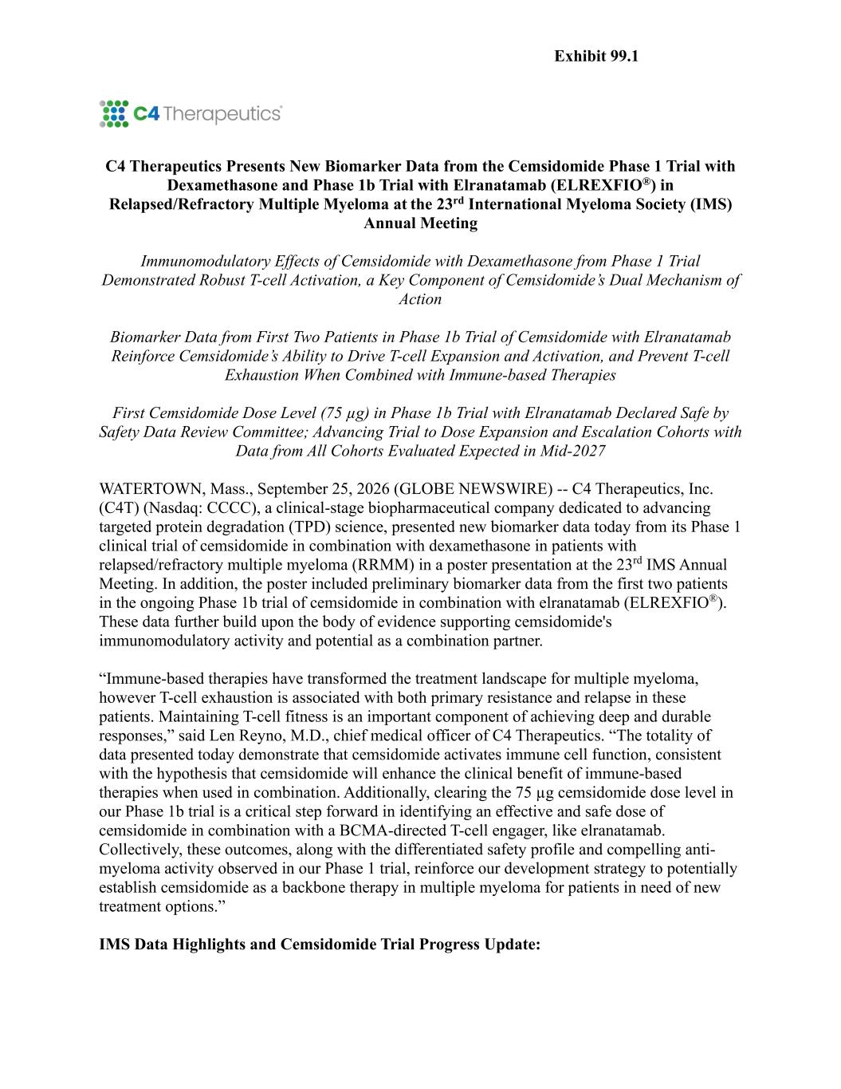

C4 Therapeutics Presents New Biomarker Data from the Cemsidomide Phase 1 Trial with Dexamethasone and Phase 1b Trial with Elranatamab (ELREXFIO®) in Relapsed/Refractory Multiple Myeloma at the 23rd International Myeloma Society (IMS) Annual Meeting Immunomodulatory Effects of Cemsidomide with Dexamethasone from Phase 1 Trial Demonstrated Robust T-cell Activation, a Key Component of Cemsidomide’s Dual Mechanism of Action Biomarker Data from First Two Patients in Phase 1b Trial of Cemsidomide with Elranatamab Reinforce Cemsidomide’s Ability to Drive T-cell Expansion and Activation, and Prevent T-cell Exhaustion When Combined with Immune-based Therapies First Cemsidomide Dose Level (75 µg) in Phase 1b Trial with Elranatamab Declared Safe by Safety Data Review Committee; Advancing Trial to Dose Expansion and Escalation Cohorts with Data from All Cohorts Evaluated Expected in Mid-2027 WATERTOWN, Mass., September 25, 2026 (GLOBE NEWSWIRE) -- C4 Therapeutics, Inc. (C4T) (Nasdaq: CCCC), a clinical-stage biopharmaceutical company dedicated to advancing targeted protein degradation (TPD) science, presented new biomarker data today from its Phase 1 clinical trial of cemsidomide in combination with dexamethasone in patients with relapsed/refractory multiple myeloma (RRMM) in a poster presentation at the 23rd IMS Annual Meeting. In addition, the poster included preliminary biomarker data from the first two patients in the ongoing Phase 1b trial of cemsidomide in combination with elranatamab (ELREXFIO®). These data further build upon the body of evidence supporting cemsidomide's immunomodulatory activity and potential as a combination partner. “Immune-based therapies have transformed the treatment landscape for multiple myeloma, however T-cell exhaustion is associated with both primary resistance and relapse in these patients. Maintaining T-cell fitness is an important component of achieving deep and durable responses,” said Len Reyno, M.D., chief medical officer of C4 Therapeutics. “The totality of data presented today demonstrate that cemsidomide activates immune cell function, consistent with the hypothesis that cemsidomide will enhance the clinical benefit of immune-based therapies when used in combination. Additionally, clearing the 75 µg cemsidomide dose level in our Phase 1b trial is a critical step forward in identifying an effective and safe dose of cemsidomide in combination with a BCMA-directed T-cell engager, like elranatamab. Collectively, these outcomes, along with the differentiated safety profile and compelling anti- myeloma activity observed in our Phase 1 trial, reinforce our development strategy to potentially establish cemsidomide as a backbone therapy in multiple myeloma for patients in need of new treatment options.” IMS Data Highlights and Cemsidomide Trial Progress Update: Exhibit 99.1

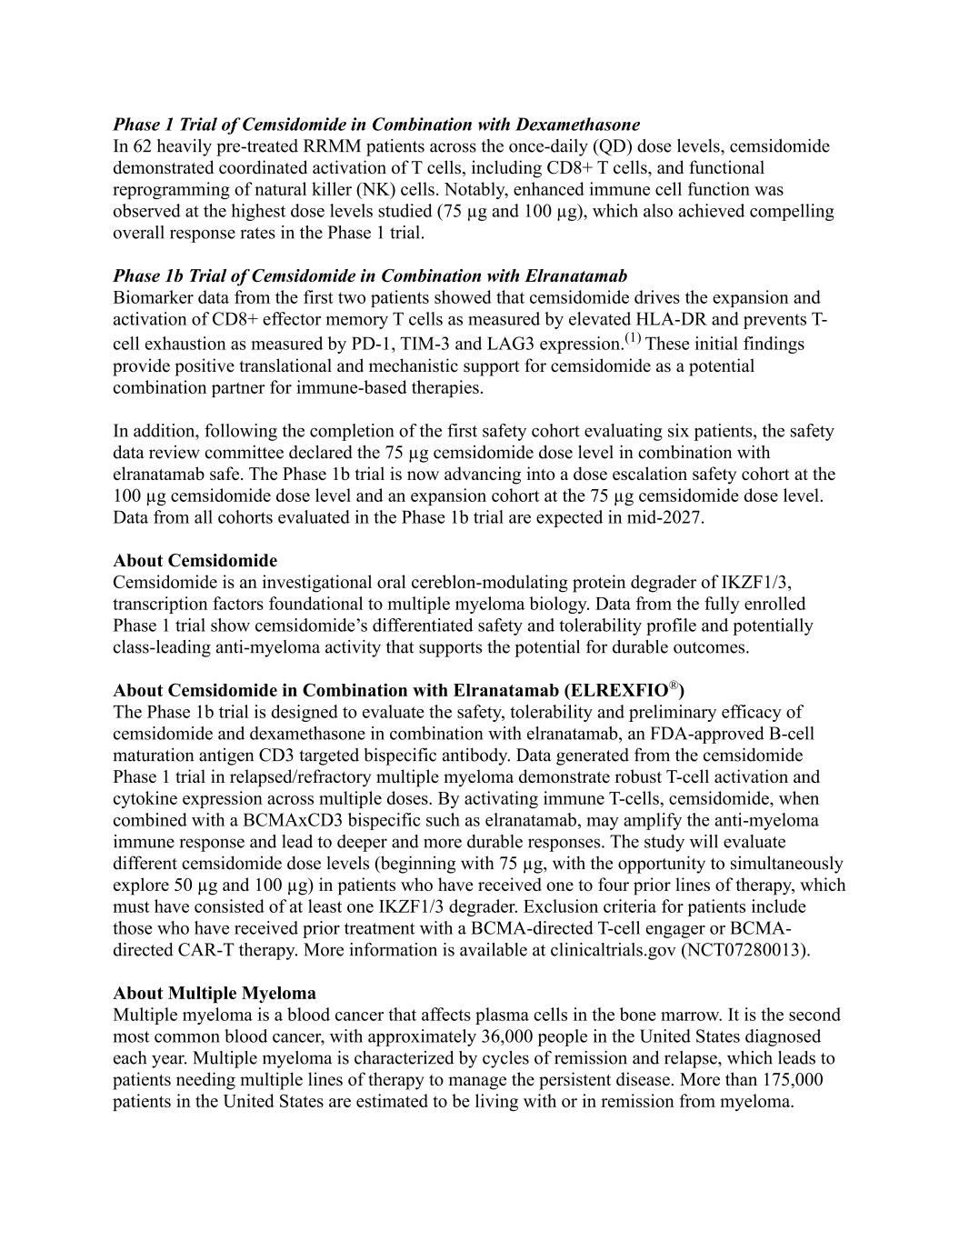
Phase 1 Trial of Cemsidomide in Combination with Dexamethasone In 62 heavily pre-treated RRMM patients across the once-daily (QD) dose levels, cemsidomide demonstrated coordinated activation of T cells, including CD8+ T cells, and functional reprogramming of natural killer (NK) cells. Notably, enhanced immune cell function was observed at the highest dose levels studied (75 µg and 100 µg), which also achieved compelling overall response rates in the Phase 1 trial. Phase 1b Trial of Cemsidomide in Combination with Elranatamab Biomarker data from the first two patients showed that cemsidomide drives the expansion and activation of CD8+ effector memory T cells as measured by elevated HLA-DR and prevents T- cell exhaustion as measured by PD-1, TIM-3 and LAG3 expression.(1) These initial findings provide positive translational and mechanistic support for cemsidomide as a potential combination partner for immune-based therapies. In addition, following the completion of the first safety cohort evaluating six patients, the safety data review committee declared the 75 µg cemsidomide dose level in combination with elranatamab safe. The Phase 1b trial is now advancing into a dose escalation safety cohort at the 100 µg cemsidomide dose level and an expansion cohort at the 75 µg cemsidomide dose level. Data from all cohorts evaluated in the Phase 1b trial are expected in mid-2027. About Cemsidomide Cemsidomide is an investigational oral cereblon-modulating protein degrader of IKZF1/3, transcription factors foundational to multiple myeloma biology. Data from the fully enrolled Phase 1 trial show cemsidomide’s differentiated safety and tolerability profile and potentially class-leading anti-myeloma activity that supports the potential for durable outcomes. About Cemsidomide in Combination with Elranatamab (ELREXFIO®) The Phase 1b trial is designed to evaluate the safety, tolerability and preliminary efficacy of cemsidomide and dexamethasone in combination with elranatamab, an FDA-approved B-cell maturation antigen CD3 targeted bispecific antibody. Data generated from the cemsidomide Phase 1 trial in relapsed/refractory multiple myeloma demonstrate robust T-cell activation and cytokine expression across multiple doses. By activating immune T-cells, cemsidomide, when combined with a BCMAxCD3 bispecific such as elranatamab, may amplify the anti-myeloma immune response and lead to deeper and more durable responses. The study will evaluate different cemsidomide dose levels (beginning with 75 µg, with the opportunity to simultaneously explore 50 µg and 100 µg) in patients who have received one to four prior lines of therapy, which must have consisted of at least one IKZF1/3 degrader. Exclusion criteria for patients include those who have received prior treatment with a BCMA-directed T-cell engager or BCMA- directed CAR-T therapy. More information is available at clinicaltrials.gov (NCT07280013). About Multiple Myeloma Multiple myeloma is a blood cancer that affects plasma cells in the bone marrow. It is the second most common blood cancer, with approximately 36,000 people in the United States diagnosed each year. Multiple myeloma is characterized by cycles of remission and relapse, which leads to patients needing multiple lines of therapy to manage the persistent disease. More than 175,000 patients in the United States are estimated to be living with or in remission from myeloma.

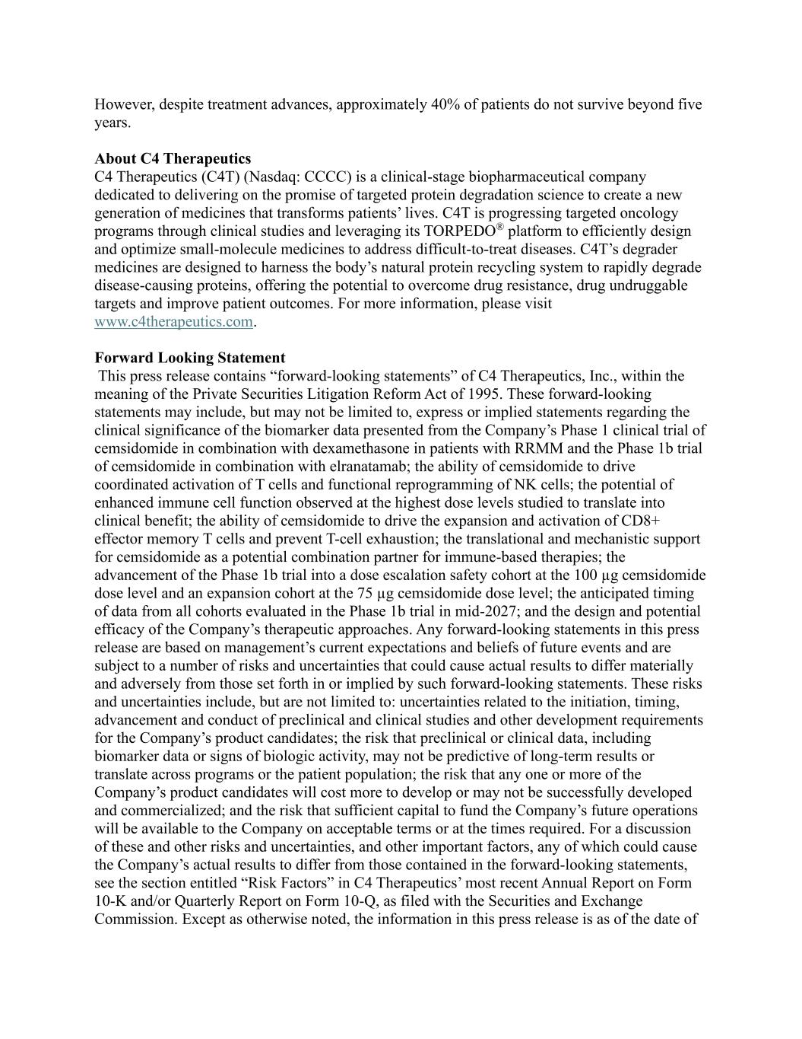
However, despite treatment advances, approximately 40% of patients do not survive beyond five years. About C4 Therapeutics C4 Therapeutics (C4T) (Nasdaq: CCCC) is a clinical-stage biopharmaceutical company dedicated to delivering on the promise of targeted protein degradation science to create a new generation of medicines that transforms patients’ lives. C4T is progressing targeted oncology programs through clinical studies and leveraging its TORPEDO® platform to efficiently design and optimize small-molecule medicines to address difficult-to-treat diseases. C4T’s degrader medicines are designed to harness the body’s natural protein recycling system to rapidly degrade disease-causing proteins, offering the potential to overcome drug resistance, drug undruggable targets and improve patient outcomes. For more information, please visit www.c4therapeutics.com. Forward Looking Statement This press release contains “forward-looking statements” of C4 Therapeutics, Inc., within the meaning of the Private Securities Litigation Reform Act of 1995. These forward-looking statements may include, but may not be limited to, express or implied statements regarding the clinical significance of the biomarker data presented from the Company’s Phase 1 clinical trial of cemsidomide in combination with dexamethasone in patients with RRMM and the Phase 1b trial of cemsidomide in combination with elranatamab; the ability of cemsidomide to drive coordinated activation of T cells and functional reprogramming of NK cells; the potential of enhanced immune cell function observed at the highest dose levels studied to translate into clinical benefit; the ability of cemsidomide to drive the expansion and activation of CD8+ effector memory T cells and prevent T-cell exhaustion; the translational and mechanistic support for cemsidomide as a potential combination partner for immune-based therapies; the advancement of the Phase 1b trial into a dose escalation safety cohort at the 100 µg cemsidomide dose level and an expansion cohort at the 75 µg cemsidomide dose level; the anticipated timing of data from all cohorts evaluated in the Phase 1b trial in mid-2027; and the design and potential efficacy of the Company’s therapeutic approaches. Any forward-looking statements in this press release are based on management’s current expectations and beliefs of future events and are subject to a number of risks and uncertainties that could cause actual results to differ materially and adversely from those set forth in or implied by such forward-looking statements. These risks and uncertainties include, but are not limited to: uncertainties related to the initiation, timing, advancement and conduct of preclinical and clinical studies and other development requirements for the Company’s product candidates; the risk that preclinical or clinical data, including biomarker data or signs of biologic activity, may not be predictive of long-term results or translate across programs or the patient population; the risk that any one or more of the Company’s product candidates will cost more to develop or may not be successfully developed and commercialized; and the risk that sufficient capital to fund the Company’s future operations will be available to the Company on acceptable terms or at the times required. For a discussion of these and other risks and uncertainties, and other important factors, any of which could cause the Company’s actual results to differ from those contained in the forward-looking statements, see the section entitled “Risk Factors” in C4 Therapeutics’ most recent Annual Report on Form 10-K and/or Quarterly Report on Form 10-Q, as filed with the Securities and Exchange Commission. Except as otherwise noted, the information in this press release is as of the date of

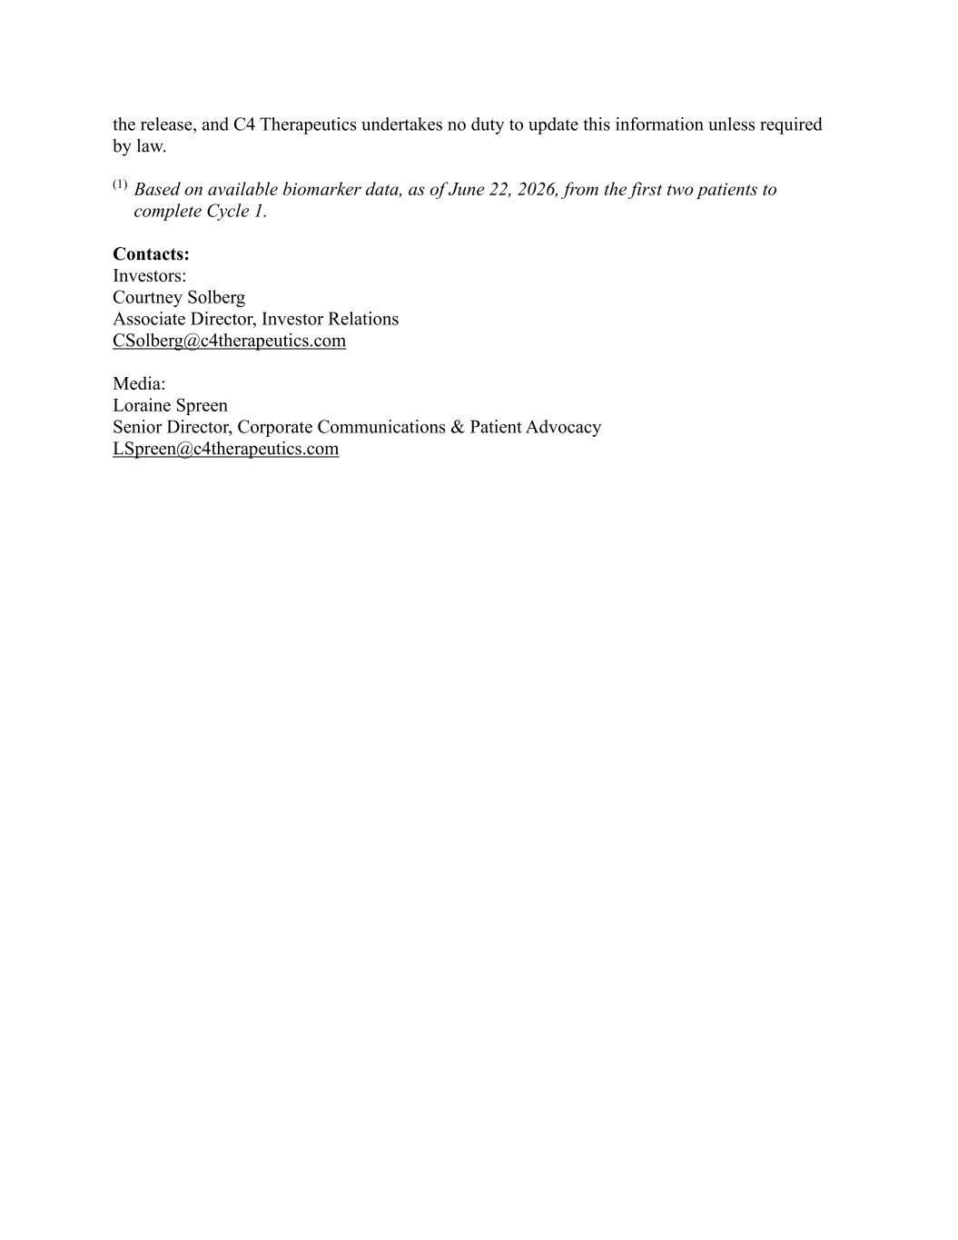
the release, and C4 Therapeutics undertakes no duty to update this information unless required by law. (1) Based on available biomarker data, as of June 22, 2026, from the first two patients to complete Cycle 1. Contacts: Investors: Courtney Solberg Associate Director, Investor Relations CSolberg@c4therapeutics.com Media: Loraine Spreen Senior Director, Corporate Communications & Patient Advocacy LSpreen@c4therapeutics.com

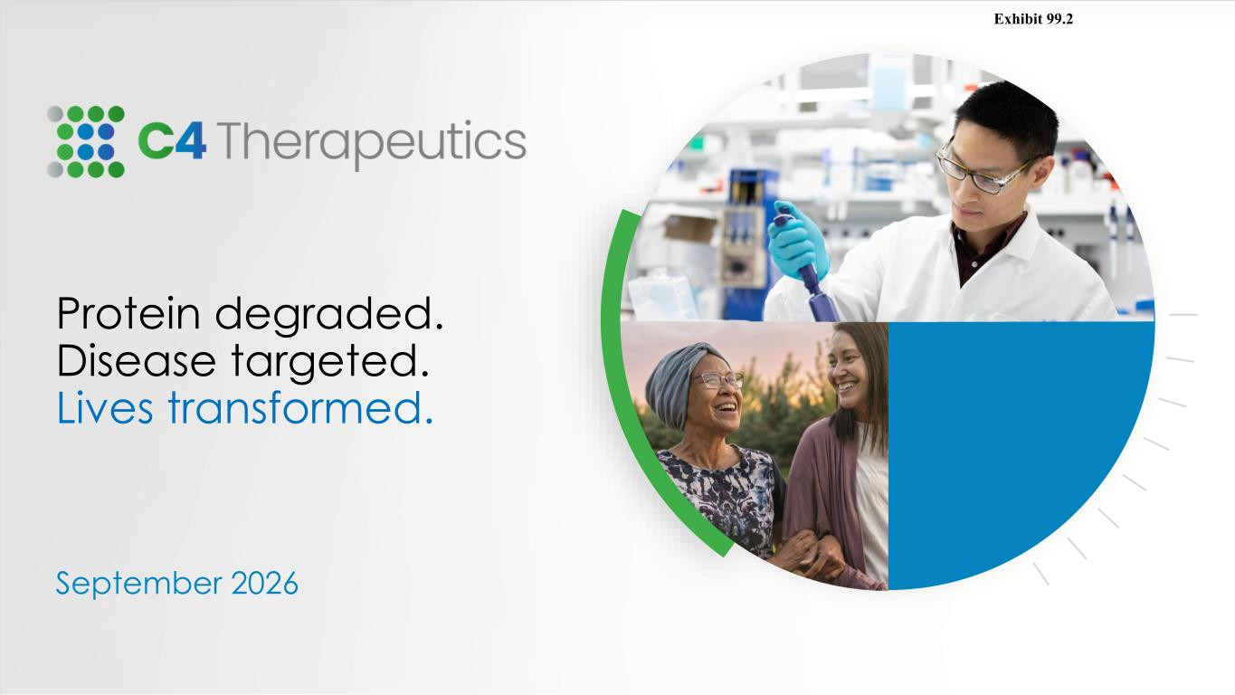
Protein degraded. Disease targeted. Lives transformed. September 2026 Exhibit 99.2

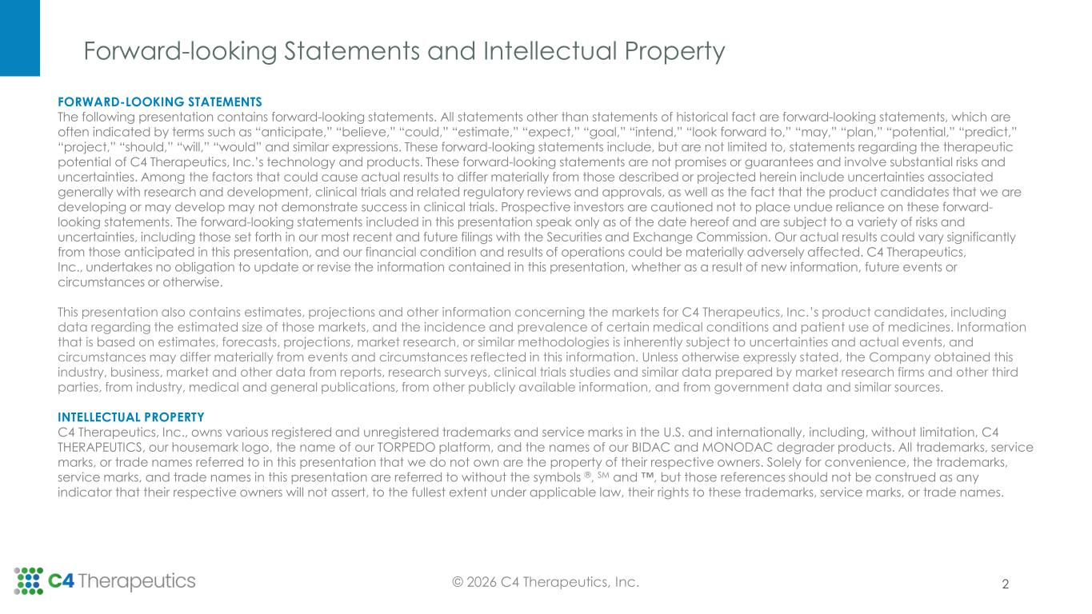
Forward-looking Statements and Intellectual Property 2 FORWARD-LOOKING STATEMENTS The following presentation contains forward-looking statements. All statements other than statements of historical fact are forward-looking statements, which are often indicated by terms such as “anticipate,” “believe,” “could,” “estimate,” “expect,” “goal,” “intend,” “look forward to,” “may,” “plan,” “potential,” “predict,” “project,” “should,” “will,” “would” and similar expressions. These forward-looking statements include, but are not limited to, statements regarding the therapeutic potential of C4 Therapeutics, Inc.’s technology and products. These forward-looking statements are not promises or guarantees and involve substantial risks and uncertainties. Among the factors that could cause actual results to differ materially from those described or projected herein include uncertainties associated generally with research and development, clinical trials and related regulatory reviews and approvals, as well as the fact that the product candidates that we are developing or may develop may not demonstrate success in clinical trials. Prospective investors are cautioned not to place undue reliance on these forward- looking statements. The forward-looking statements included in this presentation speak only as of the date hereof and are subject to a variety of risks and uncertainties, including those set forth in our most recent and future filings with the Securities and Exchange Commission. Our actual results could vary significantly from those anticipated in this presentation, and our financial condition and results of operations could be materially adversely affected. C4 Therapeutics, Inc., undertakes no obligation to update or revise the information contained in this presentation, whether as a result of new information, future events or circumstances or otherwise. This presentation also contains estimates, projections and other information concerning the markets for C4 Therapeutics, Inc.’s product candidates, including data regarding the estimated size of those markets, and the incidence and prevalence of certain medical conditions and patient use of medicines. Information that is based on estimates, forecasts, projections, market research, or similar methodologies is inherently subject to uncertainties and actual events, and circumstances may differ materially from events and circumstances reflected in this information. Unless otherwise expressly stated, the Company obtained this industry, business, market and other data from reports, research surveys, clinical trials studies and similar data prepared by market research firms and other third parties, from industry, medical and general publications, from other publicly available information, and from government data and similar sources. INTELLECTUAL PROPERTY C4 Therapeutics, Inc., owns various registered and unregistered trademarks and service marks in the U.S. and internationally, including, without limitation, C4 THERAPEUTICS, our housemark logo, the name of our TORPEDO platform, and the names of our BIDAC and MONODAC degrader products. All trademarks, service marks, or trade names referred to in this presentation that we do not own are the property of their respective owners. Solely for convenience, the trademarks, service marks, and trade names in this presentation are referred to without the symbols ®, SM and , but those references should not be construed as any indicator that their respective owners will not assert, to the fullest extent under applicable law, their rights to these trademarks, service marks, or trade names. © 2026 C4 Therapeutics, Inc.

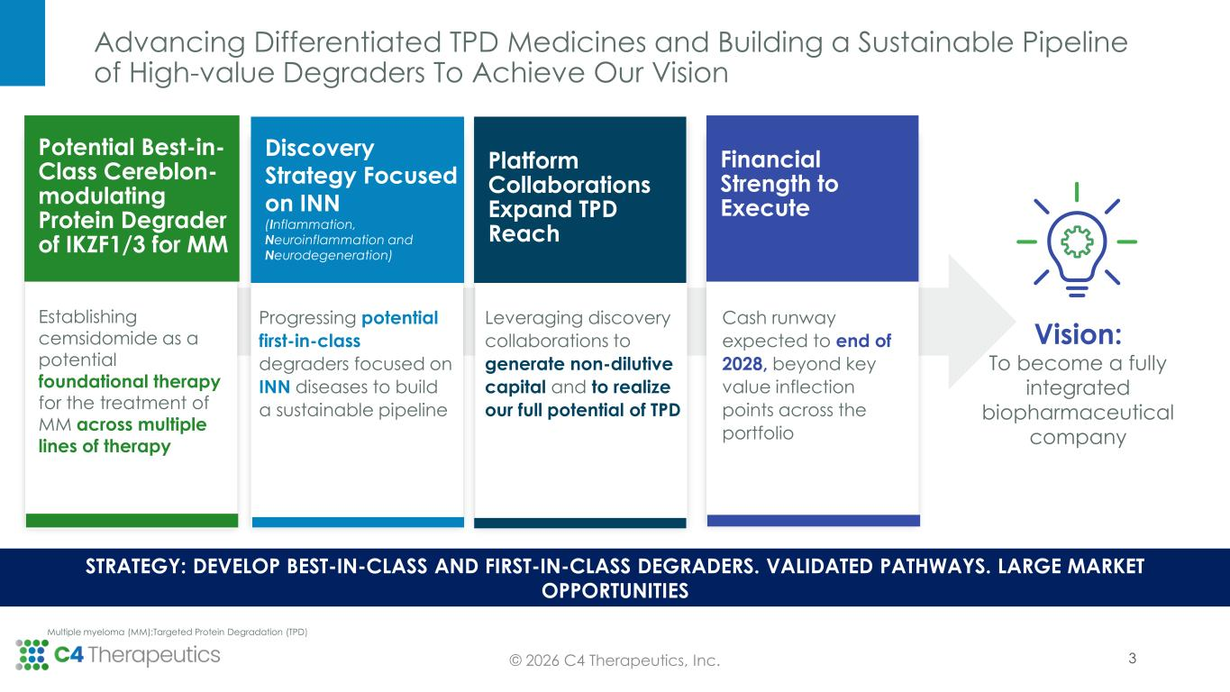
Advancing Differentiated TPD Medicines and Building a Sustainable Pipeline of High-value Degraders To Achieve Our Vision 3© 2026 C4 Therapeutics, Inc. STRATEGY: DEVELOP BEST-IN-CLASS AND FIRST-IN-CLASS DEGRADERS. VALIDATED PATHWAYS. LARGE MARKET OPPORTUNITIES Multiple myeloma (MM);Targeted Protein Degradation (TPD) Potential Best-in- Class Cereblon- modulating Protein Degrader of IKZF1/3 for MM Discovery Strategy Focused on INN (Inflammation, Neuroinflammation and Neurodegeneration) Financial Strength to Execute Establishing cemsidomide as a potential foundational therapy for the treatment of MM across multiple lines of therapy Progressing potential first-in-class degraders focused on INN diseases to build a sustainable pipeline Cash runway expected to end of 2028, beyond key value inflection points across the portfolio Vision: To become a fully integrated biopharmaceutical company Platform Collaborations Expand TPD Reach Leveraging discovery collaborations to generate non-dilutive capital and to realize our full potential of TPD

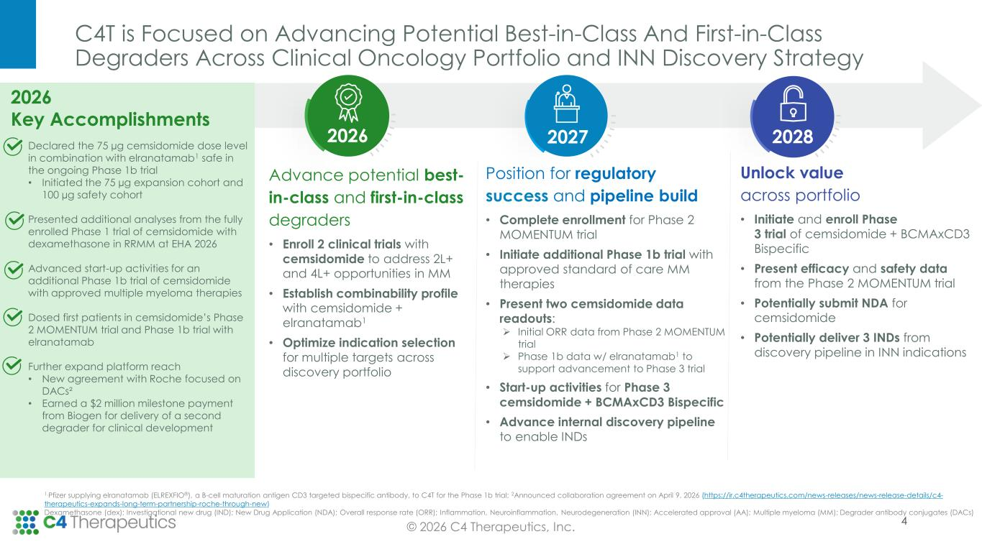
C4T is Focused on Advancing Potential Best-in-Class And First-in-Class Degraders Across Clinical Oncology Portfolio and INN Discovery Strategy © 2026 C4 Therapeutics, Inc. Advance potential best- in-class and first-in-class degraders • Enroll 2 clinical trials with cemsidomide to address 2L+ and 4L+ opportunities in MM • Establish combinability profile with cemsidomide + elranatamab1 • Optimize indication selection for multiple targets across discovery portfolio Unlock value across portfolio • Initiate and enroll Phase 3 trial of cemsidomide + BCMAxCD3 Bispecific • Present efficacy and safety data from the Phase 2 MOMENTUM trial • Potentially submit NDA for cemsidomide • Potentially deliver 3 INDs from discovery pipeline in INN indications Position for regulatory success and pipeline build • Complete enrollment for Phase 2 MOMENTUM trial • Initiate additional Phase 1b trial with approved standard of care MM therapies • Present two cemsidomide data readouts: ➢ Initial ORR data from Phase 2 MOMENTUM trial ➢ Phase 1b data w/ elranatamab1 to support advancement to Phase 3 trial • Start-up activities for Phase 3 cemsidomide + BCMAxCD3 Bispecific • Advance internal discovery pipeline to enable INDs 202820272026 1.Pfizer supplying elranatamab (ELREXFIO®), a B-cell maturation antigen CD3 targeted bispecific antibody, to C4T for the Phase 1b trial; 2Announced collaboration agreement on April 9, 2026 (https://ir.c4therapeutics.com/news-releases/news-release-details/c4- therapeutics-expands-long-term-partnership-roche-through-new) Dexamethasone (dex); Investigational new drug (IND); New Drug Application (NDA); Overall response rate (ORR); Inflammation, Neuroinflammation, Neurodegeneration (INN); Accelerated approval (AA); Multiple myeloma (MM); Degrader antibody conjugates (DACs) 4 2026 Key Accomplishments Declared the 75 µg cemsidomide dose level in combination with elranatamab1 safe in the ongoing Phase 1b trial • Initiated the 75 µg expansion cohort and 100 µg safety cohort Presented additional analyses from the fully enrolled Phase 1 trial of cemsidomide with dexamethasone in RRMM at EHA 2026 Advanced start-up activities for an additional Phase 1b trial of cemsidomide with approved multiple myeloma therapies Dosed first patients in cemsidomide’s Phase 2 MOMENTUM trial and Phase 1b trial with elranatamab Further expand platform reach • New agreement with Roche focused on DACs² • Earned a $2 million milestone payment from Biogen for delivery of a second degrader for clinical development

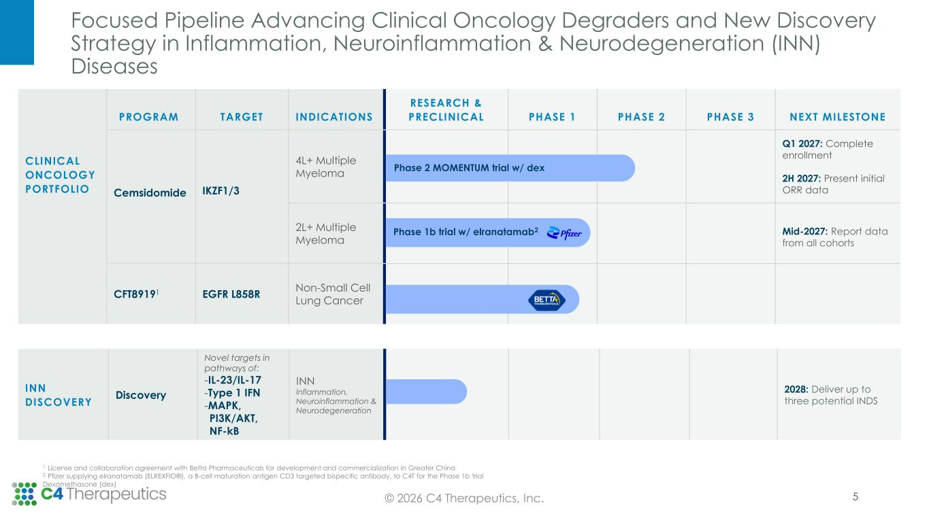
Focused Pipeline Advancing Clinical Oncology Degraders and New Discovery Strategy in Inflammation, Neuroinflammation & Neurodegeneration (INN) Diseases 5© 2026 C4 Therapeutics, Inc. INN DISCOVERY Discovery Novel targets in pathways of: -IL-23/IL-17 -Type 1 IFN -MAPK, PI3K/AKT, NF-kB INN Inflammation, Neuroinflammation & Neurodegeneration 2028: Deliver up to three potential INDS 1. License and collaboration agreement with Betta Pharmaceuticals for development and commercialization in Greater China 2. Pfizer supplying elranatamab (ELREXFIO®), a B-cell maturation antigen CD3 targeted bispecific antibody, to C4T for the Phase 1b trial Dexamethasone (dex) CLINICAL ONCOLOGY PORTFOLIO PROGRAM TARGET INDICATIONS RESEARCH & PRECLINICAL PHASE 1 PHASE 2 PHASE 3 NEXT MILESTONE Cemsidomide IKZF1/3 4L+ Multiple Myeloma Q1 2027: Complete enrollment 2H 2027: Present initial ORR data 2L+ Multiple Myeloma Mid-2027: Report data from all cohorts CFT89191 EGFR L858R Non-Small Cell Lung Cancer Phase 2 MOMENTUM trial w/ dex Phase 1b trial w/ elranatamab2

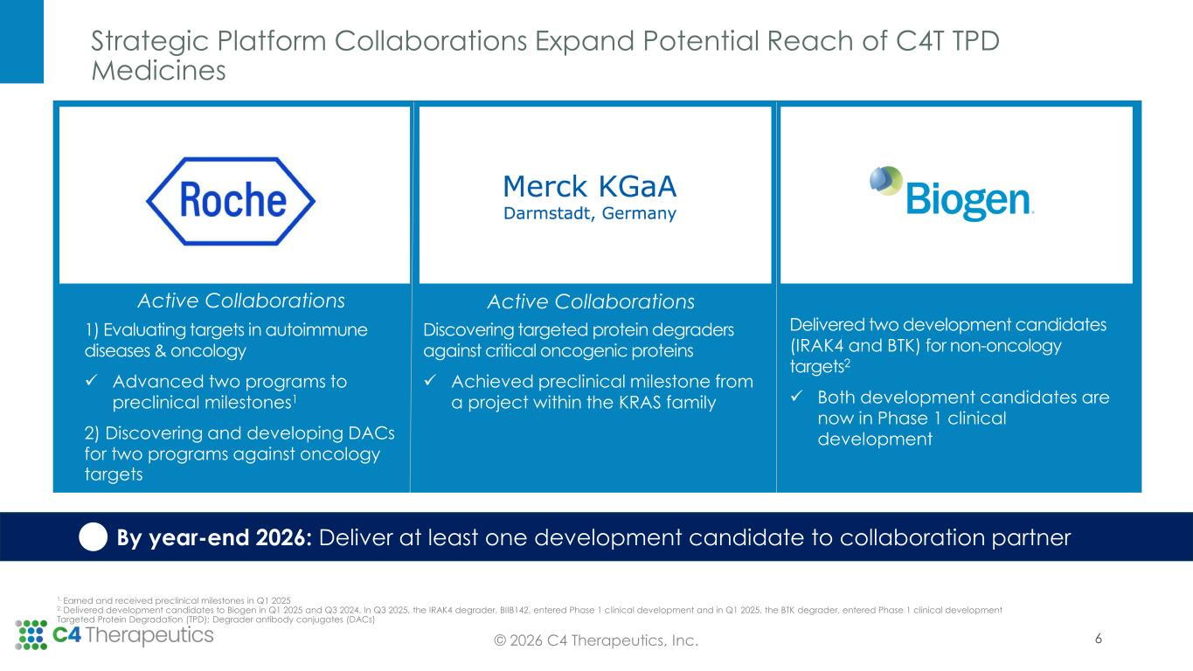
Strategic Platform Collaborations Expand Potential Reach of C4T TPD Medicines 6© 2026 C4 Therapeutics, Inc. 1. Earned and received preclinical milestones in Q1 2025 2. Delivered development candidates to Biogen in Q1 2025 and Q3 2024. In Q3 2025, the IRAK4 degrader, BIIB142, entered Phase 1 clinical development and in Q1 2025, the BTK degrader, entered Phase 1 clinical development Targeted Protein Degradation (TPD); Degrader antibody conjugates (DACs) By year-end 2026: Deliver at least one development candidate to collaboration partner 1) Evaluating targets in autoimmune diseases & oncology ✓ Advanced two programs to preclinical milestones1 2) Discovering and developing DACs for two programs against oncology targets Discovering targeted protein degraders against critical oncogenic proteins ✓ Achieved preclinical milestone from a project within the KRAS family Delivered two development candidates (IRAK4 and BTK) for non-oncology targets2 ✓ Both development candidates are now in Phase 1 clinical development Active Collaborations Active Collaborations

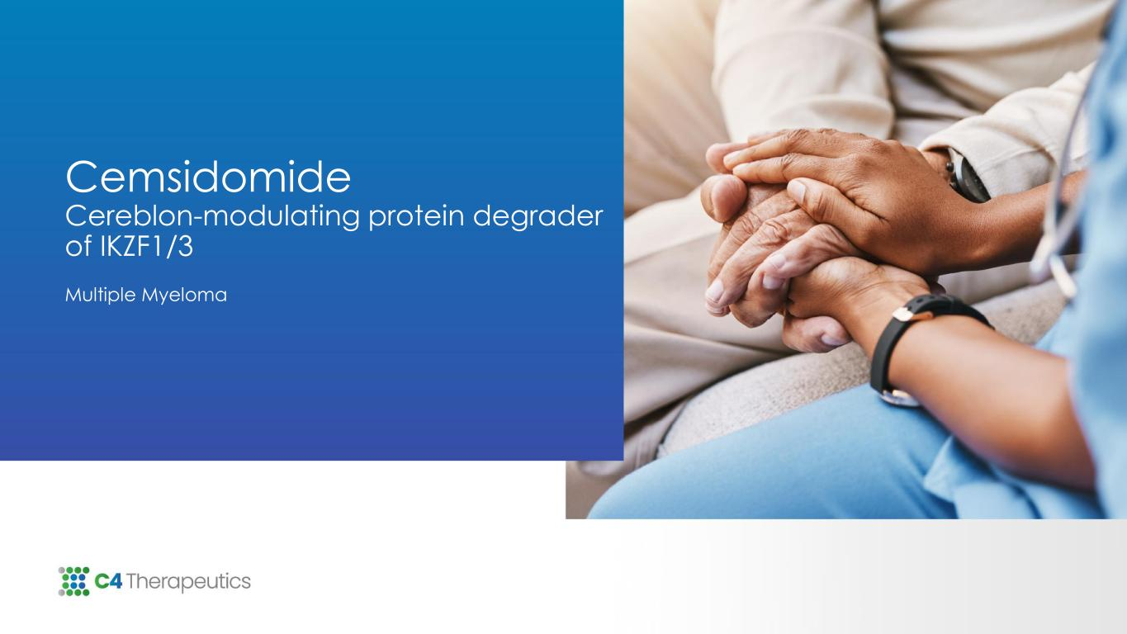
Cemsidomide Cereblon-modulating protein degrader of IKZF1/3 Multiple Myeloma

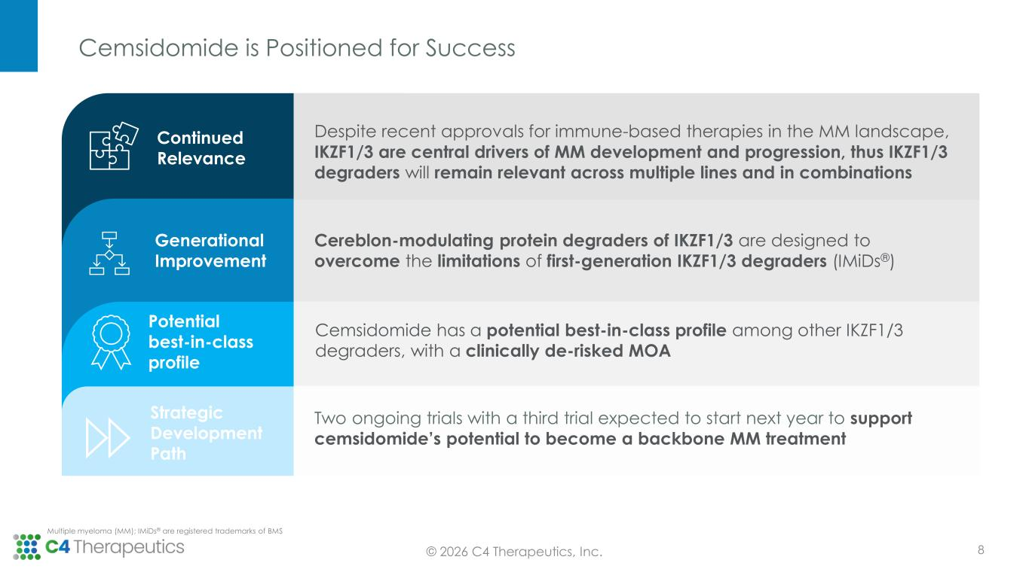
Cemsidomide is Positioned for Success © 2026 C4 Therapeutics, Inc. Multiple myeloma (MM); IMiDs® are registered trademarks of BMS Cemsidomide has a potential best-in-class profile among other IKZF1/3 degraders, with a clinically de-risked MOA Potential best-in-class profile Cereblon-modulating protein degraders of IKZF1/3 are designed to overcome the limitations of first-generation IKZF1/3 degraders (IMiDs®) Generational Improvement Despite recent approvals for immune-based therapies in the MM landscape, IKZF1/3 are central drivers of MM development and progression, thus IKZF1/3 degraders will remain relevant across multiple lines and in combinations Continued Relevance 8 Two ongoing trials with a third trial expected to start next year to support cemsidomide’s potential to become a backbone MM treatment Strategic Development Path

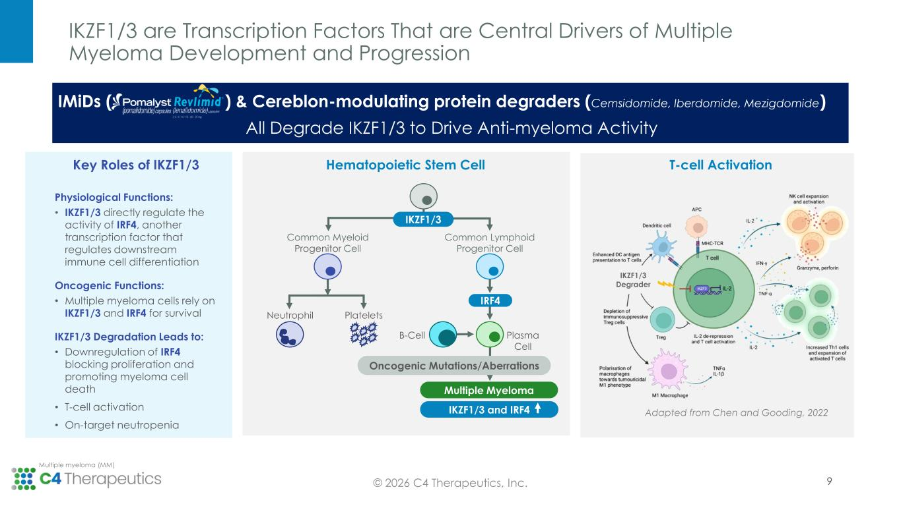
IKZF1/3 are Transcription Factors That are Central Drivers of Multiple Myeloma Development and Progression © 2026 C4 Therapeutics, Inc. Multiple myeloma (MM) 9 Physiological Functions: • IKZF1/3 directly regulate the activity of IRF4, another transcription factor that regulates downstream immune cell differentiation Oncogenic Functions: • Multiple myeloma cells rely on IKZF1/3 and IRF4 for survival IKZF1/3 Degradation Leads to: • Downregulation of IRF4 blocking proliferation and promoting myeloma cell death • T-cell activation • On-target neutropenia Key Roles of IKZF1/3 Common Myeloid Progenitor Cell Common Lymphoid Progenitor Cell Neutrophil Platelets B-Cell Plasma Cell Oncogenic Mutations/Aberrations Multiple Myeloma IRF4 IKZF1/3 and IRF4 IKZF1/3 Hematopoietic Stem Cell T-cell Activation Adapted from Chen and Gooding, 2022 IKZF1/3 Degrader IMiDs ( ) & Cereblon-modulating protein degraders (Cemsidomide, Iberdomide, Mezigdomide) All Degrade IKZF1/3 to Drive Anti-myeloma Activity

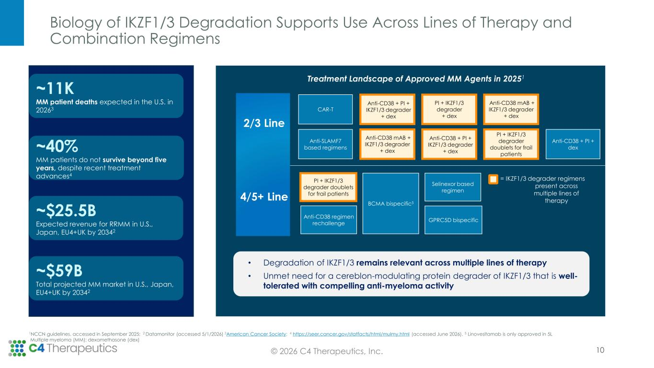
Biology of IKZF1/3 Degradation Supports Use Across Lines of Therapy and Combination Regimens 10 ~11K MM patient deaths expected in the U.S. in 20263 ~40% MM patients do not survive beyond five years, despite recent treatment advances4 ~$59B Total projected MM market in U.S., Japan, EU4+UK by 20342 2/3 Line • Degradation of IKZF1/3 remains relevant across multiple lines of therapy • Unmet need for a cereblon-modulating protein degrader of IKZF1/3 that is well- tolerated with compelling anti-myeloma activity CAR-T Anti-CD38 + PI + IKZF1/3 degrader + dex PI + IKZF1/3 degrader + dex Anti-CD38 mAB + IKZF1/3 degrader + dex Anti-SLAMF7 based regimens Anti-CD38 mAB + IKZF1/3 degrader + dex Anti-CD38 + PI + IKZF1/3 degrader + dex PI + IKZF1/3 degrader doublets for frail patients Anti-CD38 + PI + dex PI + IKZF1/3 degrader doublets for frail patients BCMA bispecific5 Selinexor based regimen Anti-CD38 regimen rechallenge GPRC5D bispecific = IKZF1/3 degrader regimens present across multiple lines of therapy Treatment Landscape of Approved MM Agents in 20251 4/5+ Line 1NCCN guidelines, accessed in September 2025; 2 Datamonitor (accessed 5/1/2026) 3American Cancer Society; 4 https://seer.cancer.gov/statfacts/html/mulmy.html (accessed June 2026). 5 Linovesltamab is only approved in 5L Multiple myeloma (MM); dexamethasone (dex) ~$25.5B Expected revenue for RRMM in U.S., Japan, EU4+UK by 20342 © 2026 C4 Therapeutics, Inc.

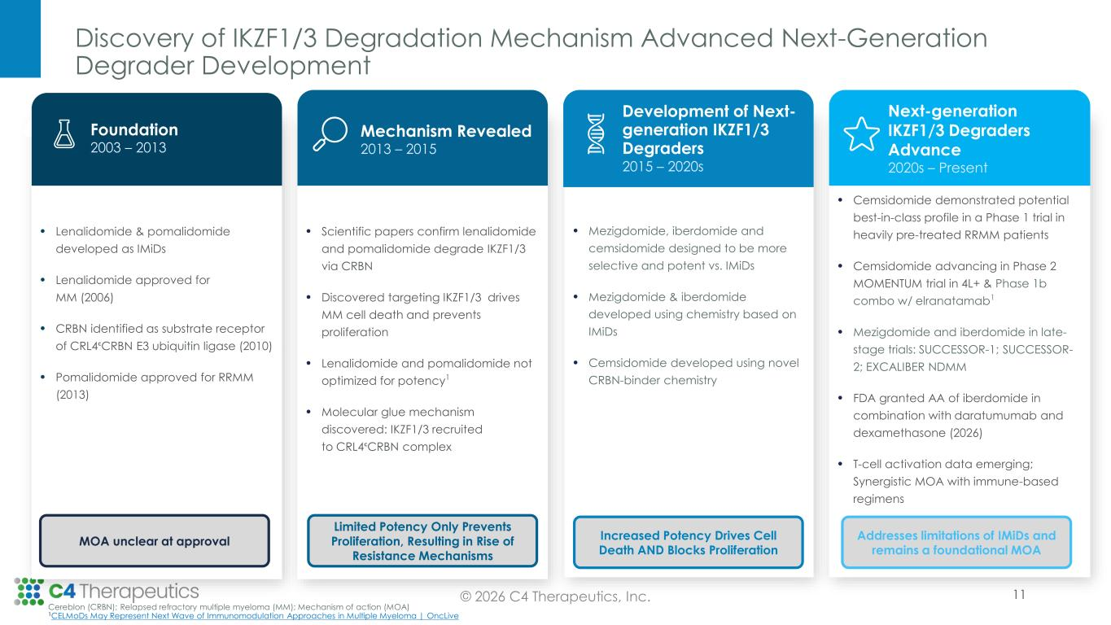
• Cemsidomide demonstrated potential best-in-class profile in a Phase 1 trial in heavily pre-treated RRMM patients • Cemsidomide advancing in Phase 2 MOMENTUM trial in 4L+ & Phase 1b combo w/ elranatamab1 • Mezigdomide and iberdomide in late- stage trials: SUCCESSOR-1; SUCCESSOR- 2; EXCALIBER NDMM • FDA granted AA of iberdomide in combination with daratumumab and dexamethasone (2026) • T-cell activation data emerging; Synergistic MOA with immune-based regimens • Lenalidomide & pomalidomide developed as IMiDs • Lenalidomide approved for MM (2006) • CRBN identified as substrate receptor of CRL4ᶜCRBN E3 ubiquitin ligase (2010) • Pomalidomide approved for RRMM (2013) Discovery of IKZF1/3 Degradation Mechanism Advanced Next-Generation Degrader Development Foundation Mechanism Revealed © 2026 C4 Therapeutics, Inc. Cereblon (CRBN); Relapsed refractory multiple myeloma (MM); Mechanism of action (MOA) 1CELMoDs May Represent Next Wave of Immunomodulation Approaches in Multiple Myeloma | OncLive Foundation 2003 – 2013 • Scientific papers confirm lenalidomide and pomalidomide degrade IKZF1/3 via CRBN • Discovered targeting IKZF1/3 drives MM cell death and prevents proliferation • Lenalidomide and pomalidomide not optimized for potency1 • Molecular glue mechanism discovered: IKZF1/3 recruited to CRL4ᶜCRBN complex Mechanism Revealed 2013 – 2015 • Mezigdomide, iberdomide and cemsidomide designed to be more selective and potent vs. IMiDs • Mezigdomide & iberdomide developed using chemistry based on IMiDs • Cemsidomide developed using novel CRBN-binder chemistry Development of Next- generation IKZF1/3 Degraders 2015 – 2020s Next-generation IKZF1/3 Degraders Advance 2020s – Present MOA unclear at approval Limited Potency Only Prevents Proliferation, Resulting in Rise of Resistance Mechanisms Increased Potency Drives Cell Death AND Blocks Proliferation Addresses limitations of IMiDs and remains a foundational MOA 11

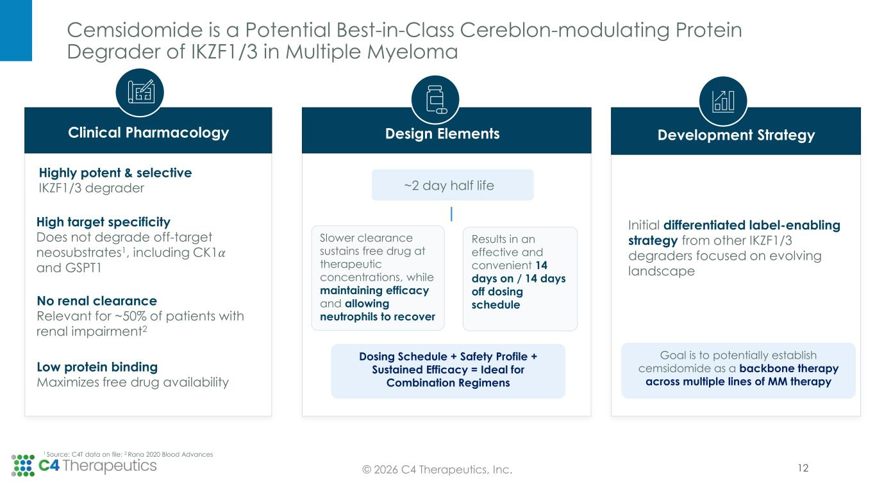
Cemsidomide is a Potential Best-in-Class Cereblon-modulating Protein Degrader of IKZF1/3 in Multiple Myeloma 12© 2026 C4 Therapeutics, Inc. Highly potent & selective IKZF1/3 degrader High target specificity Does not degrade off-target neosubstrates1, including CK1𝛼 and GSPT1 No renal clearance Relevant for ~50% of patients with renal impairment2 Low protein binding Maximizes free drug availability ~2 day half life Slower clearance sustains free drug at therapeutic concentrations, while maintaining efficacy and allowing neutrophils to recover Results in an effective and convenient 14 days on / 14 days off dosing schedule Dosing Schedule + Safety Profile + Sustained Efficacy = Ideal for Combination Regimens Initial differentiated label-enabling strategy from other IKZF1/3 degraders focused on evolving landscape Goal is to potentially establish cemsidomide as a backbone therapy across multiple lines of MM therapy 1 Source: C4T data on file; 2 Rana 2020 Blood Advances Design ElementsClinical Pharmacology Development Strategy

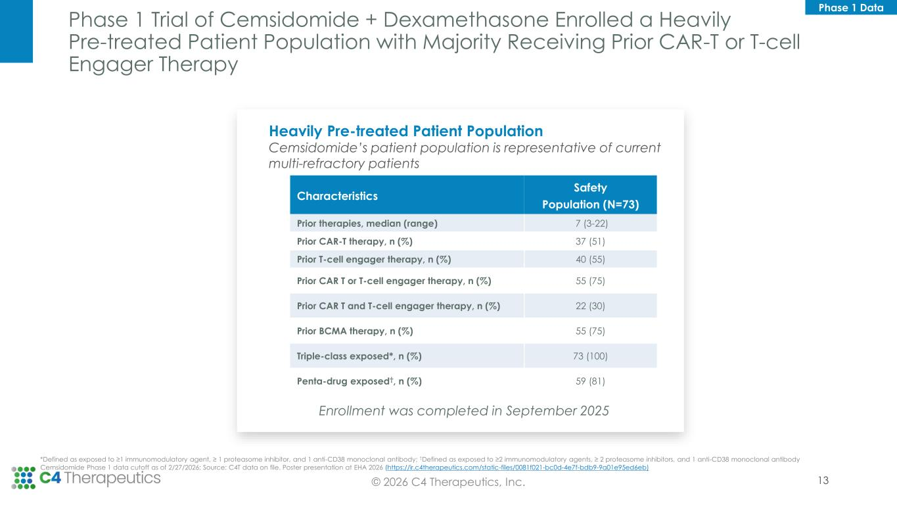
Phase 1 Trial of Cemsidomide + Dexamethasone Enrolled a Heavily Pre-treated Patient Population with Majority Receiving Prior CAR-T or T-cell Engager Therapy 13© 2026 C4 Therapeutics, Inc. Characteristics Safety Population (N=73) Prior therapies, median (range) 7 (3-22) Prior CAR-T therapy, n (%) 37 (51) Prior T-cell engager therapy, n (%) 40 (55) Prior CAR T or T-cell engager therapy, n (%) 55 (75) Prior CAR T and T-cell engager therapy, n (%) 22 (30) Prior BCMA therapy, n (%) 55 (75) Triple-class exposed*, n (%) 73 (100) Penta-drug exposed†, n (%) 59 (81) Heavily Pre-treated Patient Population Cemsidomide’s patient population is representative of current multi-refractory patients *Defined as exposed to ≥1 immunomodulatory agent, ≥ 1 proteasome inhibitor, and 1 anti-CD38 monoclonal antibody; †Defined as exposed to ≥2 immunomodulatory agents, ≥ 2 proteasome inhibitors, and 1 anti-CD38 monoclonal antibody Enrollment was completed in September 2025 Cemsidomide Phase 1 data cutoff as of 2/27/2026; Source: C4T data on file. Poster presentation at EHA 2026 (https://ir.c4therapeutics.com/static-files/0081f021-bc0d-4e7f-bdb9-9a01e95ed6eb) Phase 1 Data

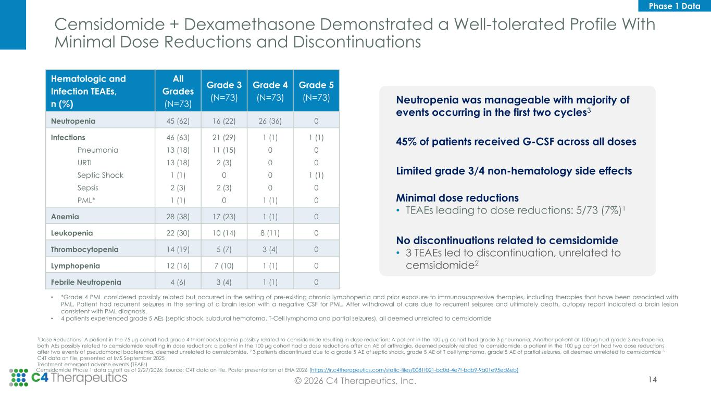
Cemsidomide + Dexamethasone Demonstrated a Well-tolerated Profile With Minimal Dose Reductions and Discontinuations 14© 2026 C4 Therapeutics, Inc. Hematologic and Infection TEAEs, n (%) All Grades (N=73) Grade 3 (N=73) Grade 4 (N=73) Grade 5 (N=73) Neutropenia 45 (62) 16 (22) 26 (36) 0 Infections Pneumonia URTI Septic Shock Sepsis PML* 46 (63) 13 (18) 13 (18) 1 (1) 2 (3) 1 (1) 21 (29) 11 (15) 2 (3) 0 2 (3) 0 1 (1) 0 0 0 0 1 (1) 1 (1) 0 0 1 (1) 0 0 Anemia 28 (38) 17 (23) 1 (1) 0 Leukopenia 22 (30) 10 (14) 8 (11) 0 Thrombocytopenia 14 (19) 5 (7) 3 (4) 0 Lymphopenia 12 (16) 7 (10) 1 (1) 0 Febrile Neutropenia 4 (6) 3 (4) 1 (1) 0 Neutropenia was manageable with majority of events occurring in the first two cycles3 45% of patients received G-CSF across all doses Limited grade 3/4 non-hematology side effects Minimal dose reductions • TEAEs leading to dose reductions: 5/73 (7%)1 No discontinuations related to cemsidomide • 3 TEAEs led to discontinuation, unrelated to cemsidomide2 • *Grade 4 PML considered possibly related but occurred in the setting of pre-existing chronic lymphopenia and prior exposure to immunosuppressive therapies, including therapies that have been associated with PML. Patient had recurrent seizures in the setting of a brain lesion with a negative CSF for PML. After withdrawal of care due to recurrent seizures and ultimately death, autopsy report indicated a brain lesion consistent with PML diagnosis. • 4 patients experienced grade 5 AEs (septic shock, subdural hematoma, T-Cell lymphoma and partial seizures), all deemed unrelated to cemsidomide 1Dose Reductions: A patient in the 75 µg cohort had grade 4 thrombocytopenia possibly related to cemsidomide resulting in dose reduction; A patient in the 100 µg cohort had grade 3 pneumonia; Another patient at 100 µg had grade 3 neutropenia, both AEs possibly related to cemsidomide resulting in dose reduction; a patient in the 100 µg cohort had a dose reductions after an AE of arthralgia, deemed possibly related to cemsidomide; a patient in the 100 µg cohort had two dose reductions after two events of pseudomonal bacteremia, deemed unrelated to cemsidomide. 2 3 patients discontinued due to a grade 5 AE of septic shock, grade 5 AE of T cell lymphoma, grade 5 AE of partial seizures, all deemed unrelated to cemsidomide 3 C4T data on file, presented at IMS September 2025 Treatment emergent adverse events (TEAEs) Cemsidomide Phase 1 data cutoff as of 2/27/2026; Source: C4T data on file. Poster presentation at EHA 2026 (https://ir.c4therapeutics.com/static-files/0081f021-bc0d-4e7f-bdb9-9a01e95ed6eb) Phase 1 Data

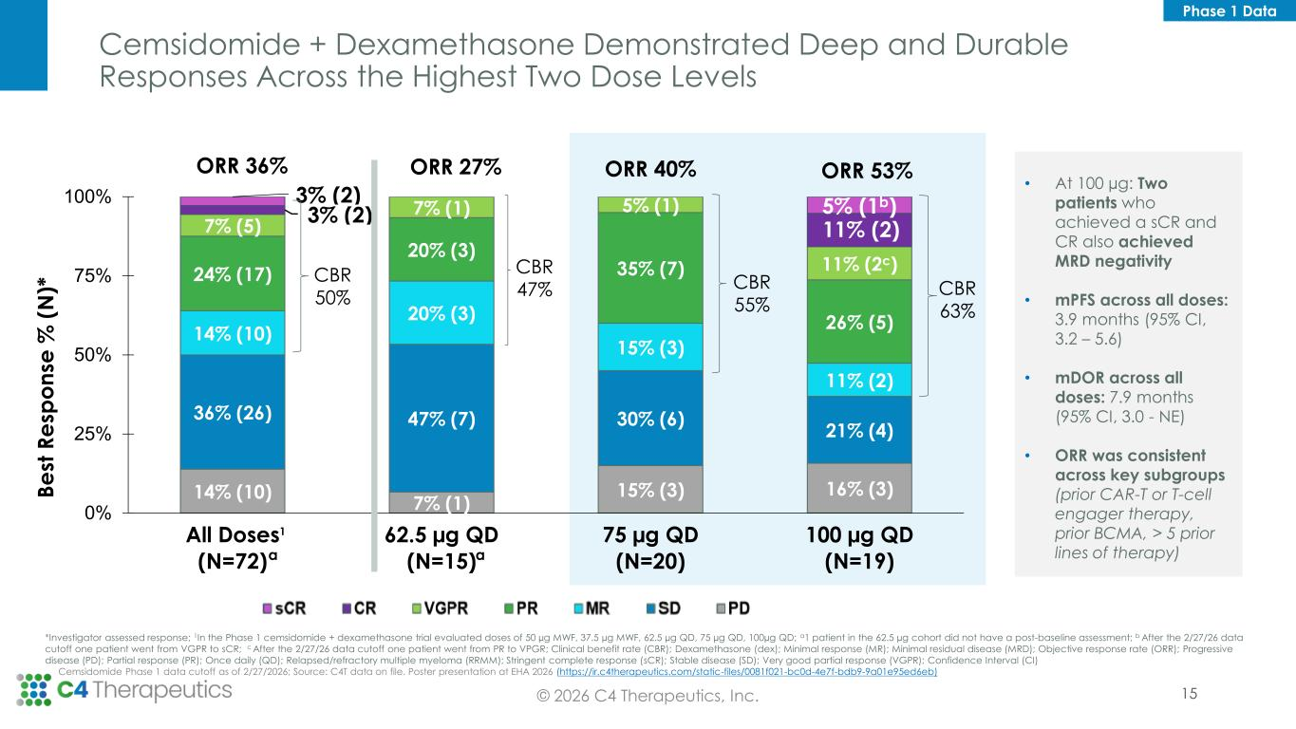
Cemsidomide + Dexamethasone Demonstrated Deep and Durable Responses Across the Highest Two Dose Levels 15© 2026 C4 Therapeutics, Inc. 14% (10) 7% (1) 15% (3) 16% (3) 36% (26) 47% (7) 30% (6) 21% (4) 14% (10) 20% (3) 15% (3) 11% (2) 24% (17) 20% (3) 35% (7) 26% (5) 7% (5) 7% (1) 5% (1) 11% (2c) 3% (2) 11% (2) 3% (2) 5% (1b) 0% 25% 50% 75% 100% All Doses (N=72) 62.5 µg QD (N=15) 75 µg QD (N=20) 100 µg QD (N=19) B e st R e sp o n se % ( N )* CBR 47% ORR 27% ORR 40%ORR 36% CBR 50% CBR 55% ORR 53% CBR 63% aa Cemsidomide Phase 1 data cutoff as of 2/27/2026; Source: C4T data on file. Poster presentation at EHA 2026 (https://ir.c4therapeutics.com/static-files/0081f021-bc0d-4e7f-bdb9-9a01e95ed6eb) *Investigator assessed response; 1In the Phase 1 cemsidomide + dexamethasone trial evaluated doses of 50 µg MWF, 37.5 µg MWF, 62.5 µg QD, 75 µg QD, 100µg QD; a1 patient in the 62.5 µg cohort did not have a post-baseline assessment; b After the 2/27/26 data cutoff one patient went from VGPR to sCR; c After the 2/27/26 data cutoff one patient went from PR to VPGR; Clinical benefit rate (CBR); Dexamethasone (dex); Minimal response (MR); Minimal residual disease (MRD); Objective response rate (ORR); Progressive disease (PD); Partial response (PR); Once daily (QD); Relapsed/refractory multiple myeloma (RRMM); Stringent complete response (sCR); Stable disease (SD); Very good partial response (VGPR); Confidence Interval (CI) 1 • At 100 µg: Two patients who achieved a sCR and CR also achieved MRD negativity • mPFS across all doses: 3.9 months (95% CI, 3.2 – 5.6) • mDOR across all doses: 7.9 months (95% CI, 3.0 - NE) • ORR was consistent across key subgroups (prior CAR-T or T-cell engager therapy, prior BCMA, > 5 prior lines of therapy) Phase 1 Data

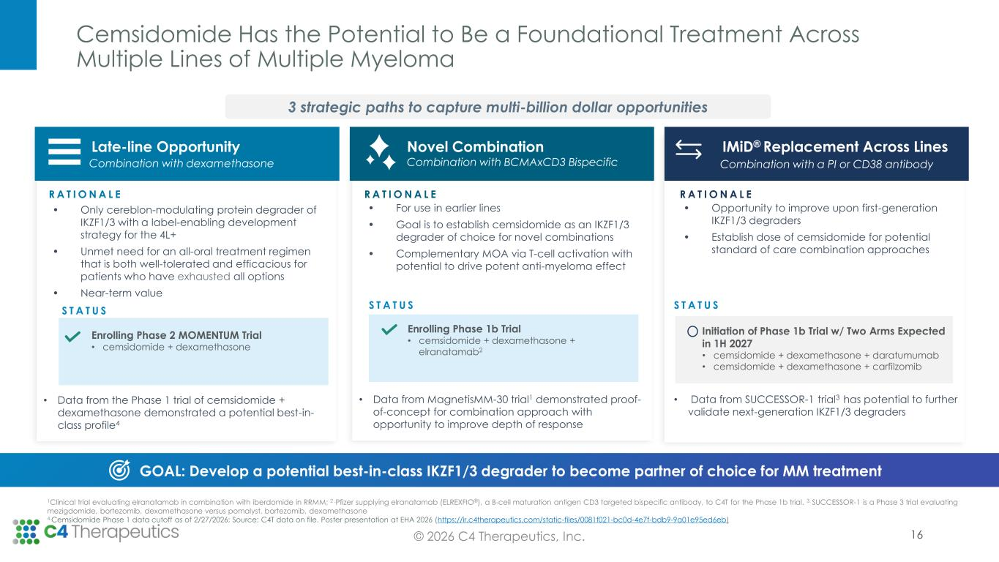
Cemsidomide Has the Potential to Be a Foundational Treatment Across Multiple Lines of Multiple Myeloma 16© 2026 C4 Therapeutics, Inc. Late-line Opportunity Combination with dexamethasone R A T I O N A L E • Only cereblon-modulating protein degrader of IKZF1/3 with a label-enabling development strategy for the 4L+ • Unmet need for an all-oral treatment regimen that is both well-tolerated and efficacious for patients who have exhausted all options • Near-term value • Data from the Phase 1 trial of cemsidomide + dexamethasone demonstrated a potential best-in- class profile4 Novel Combination Combination with BCMAxCD3 Bispecific R A T I O N A L E • For use in earlier lines • Goal is to establish cemsidomide as an IKZF1/3 degrader of choice for novel combinations • Complementary MOA via T-cell activation with potential to drive potent anti-myeloma effect • Data from MagnetisMM-30 trial1 demonstrated proof- of-concept for combination approach with opportunity to improve depth of response IMiD® Replacement Across Lines Combination with a PI or CD38 antibody R A T I O N A L E • Opportunity to improve upon first-generation IKZF1/3 degraders • Establish dose of cemsidomide for potential standard of care combination approaches • Data from SUCCESSOR-1 trial3 has potential to further validate next-generation IKZF1/3 degraders GOAL: Develop a potential best-in-class IKZF1/3 degrader to become partner of choice for MM treatment 1Clinical trial evaluating elranatamab in combination with iberdomide in RRMM; 2 .Pfizer supplying elranatamab (ELREXFIO®), a B-cell maturation antigen CD3 targeted bispecific antibody, to C4T for the Phase 1b trial. 3. SUCCESSOR-1 is a Phase 3 trial evaluating mezigdomide, bortezomib, dexamethasone versus pomalyst, bortezomib, dexamethasone 4.Cemsidomide Phase 1 data cutoff as of 2/27/2026; Source: C4T data on file. Poster presentation at EHA 2026 (https://ir.c4therapeutics.com/static-files/0081f021-bc0d-4e7f-bdb9-9a01e95ed6eb) S T A T U S Enrolling Phase 2 MOMENTUM Trial • cemsidomide + dexamethasone S T A T U S Enrolling Phase 1b Trial • cemsidomide + dexamethasone + elranatamab2 S T A T U S Initiation of Phase 1b Trial w/ Two Arms Expected in 1H 2027 • cemsidomide + dexamethasone + daratumumab • cemsidomide + dexamethasone + carfilzomib GOAL: Develop a pot ntial best-in-class IKZF1/3 degrader to become partner of choice for MM treatment 3 strategic paths to capture multi-billion dollar opportunities

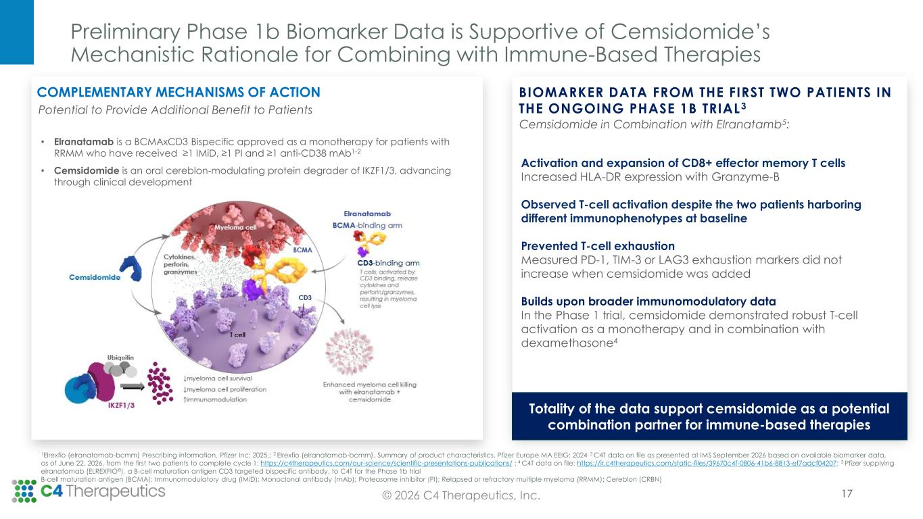
Preliminary Phase 1b Biomarker Data is Supportive of Cemsidomide’s Mechanistic Rationale for Combining with Immune-Based Therapies 17© 2026 C4 Therapeutics, Inc. • Demonstrated t-cell activation across clinically relevant doses as a monotherapy and in combination w/ dexamethasone3 BIOMARKER DATA FROM THE FIRST TWO PATIENTS IN THE ONGOING PHASE 1B TRIAL3 Activation and expansion of CD8+ effector memory T cells Increased HLA-DR expression with Granzyme-B Observed T-cell activation despite the two patients harboring different im unophenotypes at bas line Prevented T-cell exhaustion Measured PD-1, TIM-3 or LAG3 exhaustion markers did not increase when cemsidomide was added Builds upon broader immunomodulatory data In the Phase 1 trial, cemsidomide demonstrated robust T-cell activation as a monotherapy and in combination with dexamethasone4 COMPLEMENTARY MECHANISMS OF ACTION • Elranatamab is a BCMAxCD3 Bispecific approved as a monotherapy for patients with RRMM who have received ≥1 IMiD, ≥1 PI and ≥1 anti-CD38 mAb1-2 • Cemsidomide is an oral cereblon-modulating protein degrader of IKZF1/3, advancing through clinical development 1Elrexfio (elranatamab-bcmm) Prescribing information. Pfizer Inc; 2025.; 2 Elrexfio (elranatamab-bcmm). Summary of product characteristics. Pfizer Europe MA EEIG; 2024; 3 C4T data on file as presented at IMS September 2026 based on available biomarker data, as of June 22, 2026, from the first two patients to complete cycle 1: https://c4therapeutics.com/our-science/scientific-presentations-publications/ ; 4 C4T data on file: https://ir.c4therapeutics.com/static-files/39670c4f-0806-41b6-8813-ef7adcf04207; 5 Pfizer supplying elranatamab (ELREXFIO®), a B-cell maturation antigen CD3 targeted bispecific antibody, to C4T for the Phase 1b trial B-cell maturation antigen (BCMA); Immunomodulatory drug (IMiD); Monoclonal antibody (mAb); Proteasome inhibitor (PI); Relapsed or refractory multiple myeloma (RRMM); Cereblon (CRBN) Potential to Provide Additional Benefit to Patients Totality of the data support cemsidomide as a potential combination partner for immune-based therapies Cemsidomide in Combination with Elranatamb5:

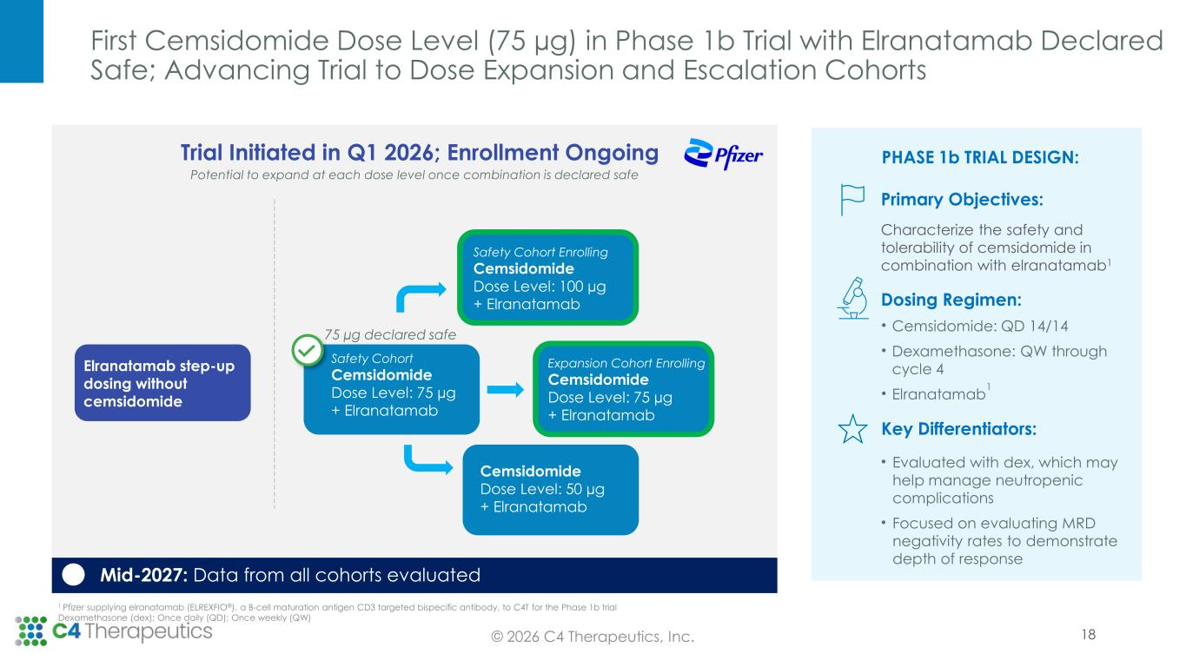
First Cemsidomide Dose Level (75 µg) in Phase 1b Trial with Elranatamab Declared Safe; Advancing Trial to Dose Expansion and Escalation Cohorts © 2026 C4 Therapeutics, Inc. 1 Pfizer supplying elranatamab (ELREXFIO®), a B-cell maturation antigen CD3 targeted bispecific antibody, to C4T for the Phase 1b trial Dexamethasone (dex); Once daily (QD); Once weekly (QW) PHASE 1b TRIAL DESIGN: Primary Objectives: Characterize the safety and tolerability of cemsidomide in combination with elranatamab1 Dosing Regimen: • Cemsidomide: QD 14/14 • Dexamethasone: QW through cycle 4 • Elranatamab 1 Key Differentiators: • Evaluated with dex, which may help manage neutropenic complications • Focused on evaluating MRD negativity rates to demonstrate depth of response 18 Safety Cohort Cemsidomide Dose Level: 75 µg + Elranatamab 75 µg declared safe Cemsidomide Dose Level: 50 µg + Elranatamab Safety Cohort Enrolling Cemsidomide Dose Level: 100 µg + Elranatamab Potential to expand at each dose level once combination is declared safe Trial Initiated in Q1 2026; Enrollment Ongoing Mid-2027: Data from all cohorts evaluated Elranatamab step-up dosing without cemsidomide Expansion Cohort Enrolling Cemsidomide Dose Level: 75 µg + Elranatamab

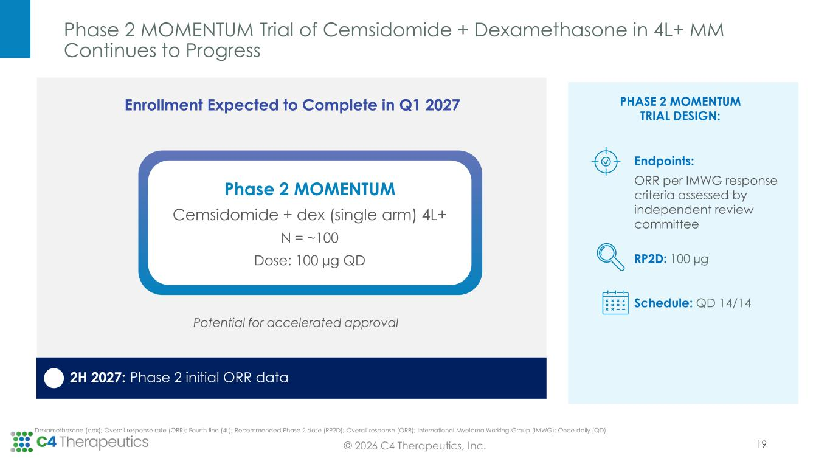
Phase 2 MOMENTUM Trial of Cemsidomide + Dexamethasone in 4L+ MM Continues to Progress © 2026 C4 Therapeutics, Inc. Dexamethasone (dex); Overall response rate (ORR); Fourth line (4L); Recommended Phase 2 dose (RP2D); Overall response (ORR); International Myeloma Working Group (IMWG); Once daily (QD) 19 Endpoints: ORR per IMWG response criteria assessed by independent review committee RP2D: 100 µg Schedule: QD 14/14 Potential for accelerated approval PHASE 2 MOMENTUM TRIAL DESIGN: 2H 2027: Phase 2 initial ORR data Phase 2 MOMENTUM Cemsidomide + dex (single arm) 4L+ N = ~100 Dose: 100 µg QD Enrollment Expected to Complete in Q1 2027

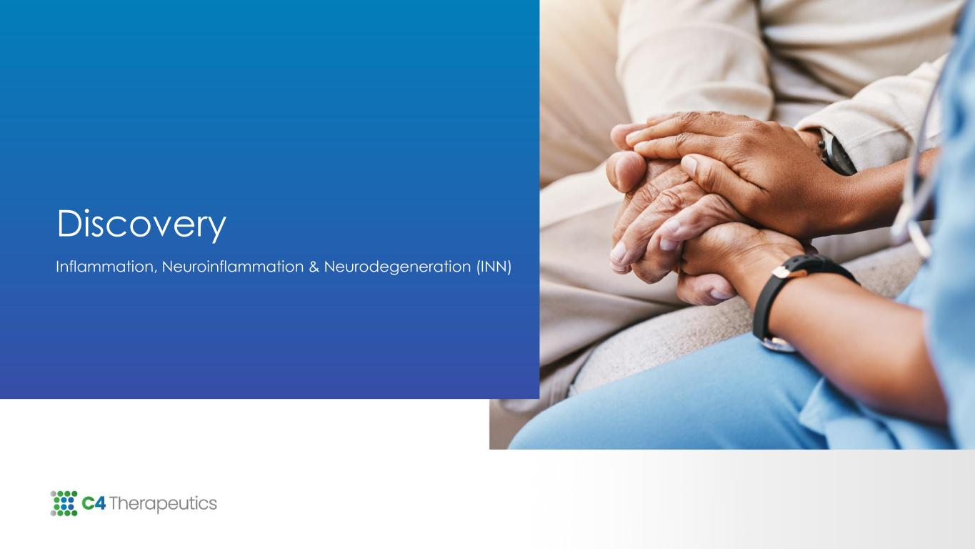
Discovery Inflammation, Neuroinflammation & Neurodegeneration (INN)

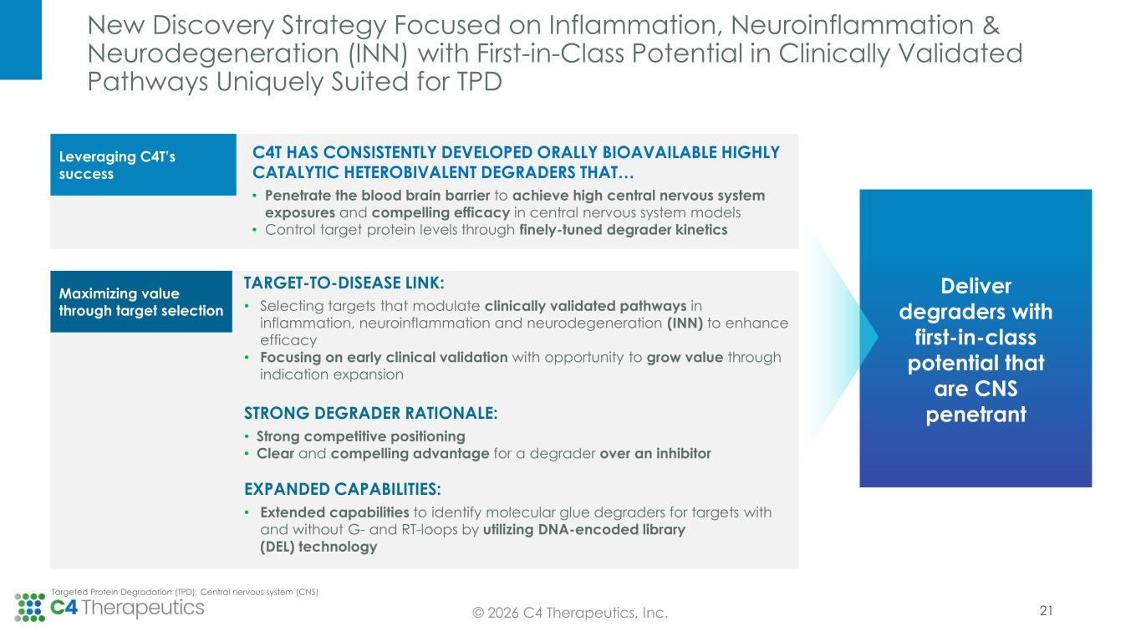
New Discovery Strategy Focused on Inflammation, Neuroinflammation & Neurodegeneration (INN) with First-in-Class Potential in Clinically Validated Pathways Uniquely Suited for TPD 21© 2026 C4 Therapeutics, Inc. Targeted Protein Degradation (TPD); Central nervous system (CNS) Leveraging C4T’s success Maximizing value through target selection Deliver degraders with first-in-class potential that are CNS penetrant C4T HAS CONSISTENTLY DEVELOPED ORALLY BIOAVAILABLE HIGHLY CATALYTIC HETEROBIVALENT DEGRADERS THAT… • Penetrate the blood brain barrier to achieve high central nervous system exposures and compelling efficacy in central nervous system models • Control target protein levels through finely-tuned degrader kinetics TARGET-TO-DISEASE LINK: • Selecting targets that modulate clinically validated pathways in inflammation, neuroinflammation and neurodegeneration (INN) to enhance efficacy • Focusing on early clinical validation with opportunity to grow value through indication expansion STRONG DEGRADER RATIONALE: • Strong competitive positioning • Clear and compelling advantage for a degrader over an inhibitor EXPANDED CAPABILITIES: • Extended capabilities to identify molecular glue degraders for targets with and without G- and RT-loops by utilizing DNA-encoded library (DEL) technology

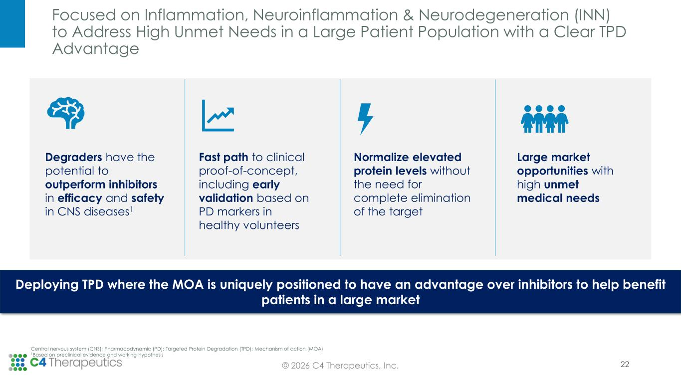
Focused on Inflammation, Neuroinflammation & Neurodegeneration (INN) to Address High Unmet Needs in a Large Patient Population with a Clear TPD Advantage © 2026 C4 Therapeutics, Inc. Central nervous system (CNS); Pharmacodynamic (PD); Targeted Protein Degradation (TPD); Mechanism of action (MOA) 1Based on preclinical evidence and working hypothesis 22 Deploying TPD where the MOA is uniquely positioned to have an advantage over inhibitors to help benefit patients in a large market Degraders have the potential to outperform inhibitors in efficacy and safety in CNS diseases1 Fast path to clinical proof-of-concept, including early validation based on PD markers in healthy volunteers Normalize elevated protein levels without the need for complete elimination of the target Large market opportunities with high unmet medical needs

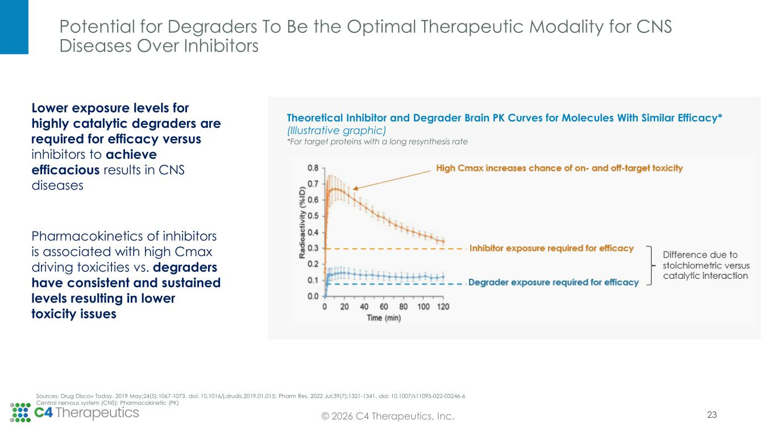
Potential for Degraders To Be the Optimal Therapeutic Modality for CNS Diseases Over Inhibitors 23 Theoretical Inhibitor and Degrader Brain PK Curves for Molecules With Similar Efficacy* (Illustrative graphic) *For target proteins with a long resynthesis rate Lower exposure levels for highly catalytic degraders are required for efficacy versus inhibitors to achieve efficacious results in CNS diseases Pharmacokinetics of inhibitors is associated with high Cmax driving toxicities vs. degraders have consistent and sustained levels resulting in lower toxicity issues Sources: Drug Discov Today. 2019 May;24(5):1067-1073. doi: 10.1016/j.drudis.2019.01.015; Pharm Res. 2022 Jul;39(7):1321-1341. doi: 10.1007/s11095-022-03246-6 Central nervous system (CNS); Pharmacokinetic (PK) © 2026 C4 Therapeutics, Inc.

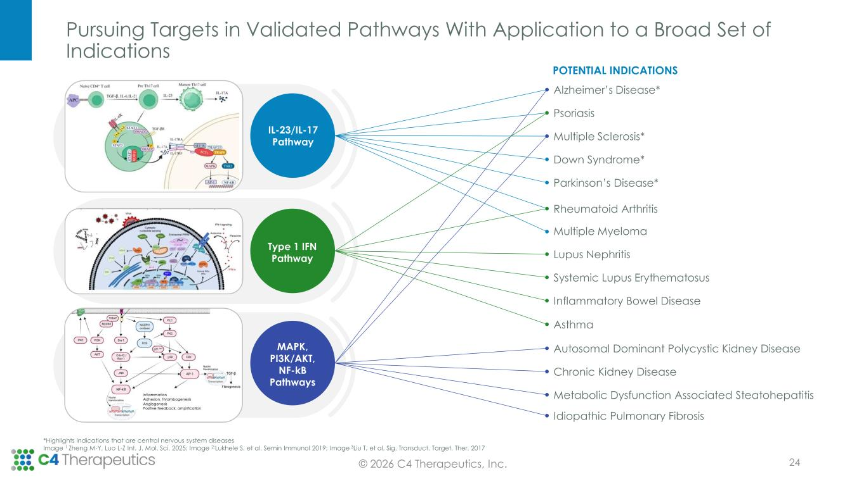
Pursuing Targets in Validated Pathways With Application to a Broad Set of Indications © 2026 C4 Therapeutics, Inc. *Highlights indications that are central nervous system diseases Image 1 Zheng M-Y, Luo L-Z Int. J. Mol. Sci. 2025; Image 2:Lukhele S, et al. Semin Immunol 2019; Image 3Liu T, et al, Sig. Transduct. Target. Ther. 2017 Alzheimer’s Disease* Psoriasis Multiple Sclerosis* Down Syndrome* Parkinson’s Disease* Rheumatoid Arthritis Multiple Myeloma Lupus Nephritis Systemic Lupus Erythematosus Inflammatory Bowel Disease Asthma Autosomal Dominant Polycystic Kidney Disease Chronic Kidney Disease Metabolic Dysfunction Associated Steatohepatitis Idiopathic Pulmonary Fibrosis POTENTIAL INDICATIONS IL-23/IL-17 Pathway Type 1 IFN Pathway MAPK, PI3K/AKT, NF-kB Pathways 24

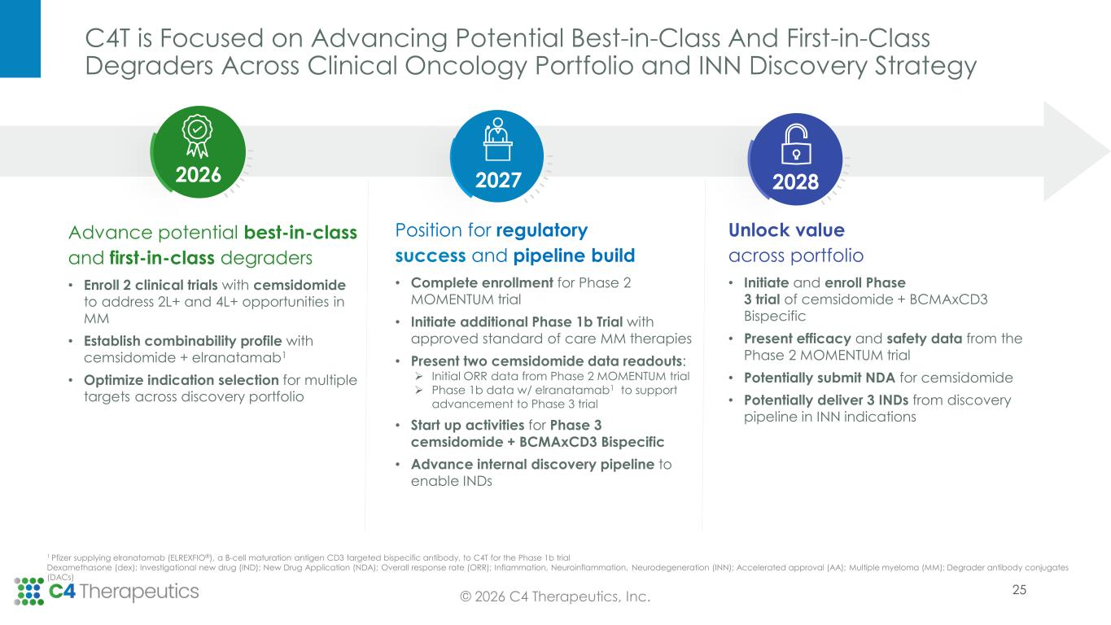
C4T is Focused on Advancing Potential Best-in-Class And First-in-Class Degraders Across Clinical Oncology Portfolio and INN Discovery Strategy © 2026 C4 Therapeutics, Inc. Advance potential best-in-class and first-in-class degraders • Enroll 2 clinical trials with cemsidomide to address 2L+ and 4L+ opportunities in MM • Establish combinability profile with cemsidomide + elranatamab1 • Optimize indication selection for multiple targets across discovery portfolio Unlock value across portfolio • Initiate and enroll Phase 3 trial of cemsidomide + BCMAxCD3 Bispecific • Present efficacy and safety data from the Phase 2 MOMENTUM trial • Potentially submit NDA for cemsidomide • Potentially deliver 3 INDs from discovery pipeline in INN indications Position for regulatory success and pipeline build • Complete enrollment for Phase 2 MOMENTUM trial • Initiate additional Phase 1b Trial with approved standard of care MM therapies • Present two cemsidomide data readouts: ➢ Initial ORR data from Phase 2 MOMENTUM trial ➢ Phase 1b data w/ elranatamab1 to support advancement to Phase 3 trial • Start up activities for Phase 3 cemsidomide + BCMAxCD3 Bispecific • Advance internal discovery pipeline to enable INDs 202820272026 1 Pfizer supplying elranatamab (ELREXFIO®), a B-cell maturation antigen CD3 targeted bispecific antibody, to C4T for the Phase 1b trial Dexamethasone (dex); Investigational new drug (IND); New Drug Application (NDA); Overall response rate (ORR); Inflammation, Neuroinflammation, Neurodegeneration (INN); Accelerated approval (AA); Multiple myeloma (MM); Degrader antibody conjugates (DACs) 25

